Film Unit Three: Story
Three types of movies: fiction, documentary and avant-garde. The latter two do not tell stories. Neither use a plot.
Narratology: the study of how stories work, how we fit them together to form a coherent whole. It is also the study of different narrative structures, story telling strategies, aesthetic conventions, types of stories (genres) and their symbolic implications.
Narratologists are interested in the rhetoric of storytelling, the forms that message senders use to communicate with message receivers. The implied author of a movie is the filmmaker.
Narratology varies with the type of film. In realistic films, the implied author is virtually invisible. The events speak for themselves. In classical stories, we are aware of a shaping hand – boring parts are left out. In formalistic stories, the author is overtly manipulative, restructuring events to maximize a thematic idea. Pulp Fiction is an example.
The classical paradigm
A term describing the narrative structure that has dominated fiction film since the 1910’2. It has conflict between a protagonist and antagonist, things escalate to a dramatic climax and then resolution. The classical paradigm emphasizes dramatic unity, plausible motivations and coherence of its parts. Stories are linear.
Buster Keaton’s The General – excellent example. Act one establishes the characters and conflict. Act two starts Keaton on the train. Mid-point: Keaton overhears Union plans and rescues his girl. From this point on, Keaton is no longer the butt of jokes. Other people are. Act 3 is a battle sequence.
Genre and myth
Genre: an example of a specific type of movie, war, gangster, science fiction, drama. There are many genres and subgenres. Look over this website’s presentation on genres:
http://www.filmsite.org/filmgenres.html
By exploiting the the broad outlines of a well known story or story type, the filmmaker can play off its main features, creating provocative tension between the genre’s conventions and the deviations, between the familiar and the original. The stylized conventions (a shoot out for example in a Western) and archetypal patterns encourage viewer participation.

Four cycles of genre movie
- Primitive. This is where the genre is created. Many conventions of the genre are established here. An example might be the first two James Bond movies.
- Classical. The genre’s conventions are fixed and instantly recognizable. Goldfinger is an example.
- Revisionist. The genre becomes stylistically more complex, appealing more to the intellect than to the emotions. The genre’s established conventions are exploited as ironic foils. The Bond reboot with Daniel Craig is an example (“would you like your martini shaken or stirred?” “Does it look like I give a damn?”)
- Parodic. This phase makes a mockery of the genre. Example: Austin Powers.
In Westerns, The Great Train Robbery is a primitive Western. John Ford’s Stagecoach is an example of the classical phase. High Noon or The Searchers are revisionist, they question the foundations of the genre. Clint Eastwood’s The Unforgiven is also an example. Satiric westerns would be parodic, such as Blazing Saddles by Mel Brooks.
Read the poetics. Aristotle distinguishes between two types of fictional narrative: mimeis (showing) and diegesis (telling). Cinema uses both.
Exposition: information the movie needs to tell us. Scenes that exist only to give important information. Example of an expository scene done well: Raiders of the Lost Ark, Indy gets important information while the audience is distracted wondering if the monkey will give Indy a poisoned fruit.
Go to Story in this slide show. Story elements begin on page 54
http://www.slideshare.net/lvterry/understanding-movies
Voice over – a narrator who tells us information that we can’t otherwise have. Worst case of film narrative: Conan the Barbarian (original. We see hero’s parents murdered and then he is sold into a decade of backbreaking slavery. Narrator then tells us “His was a tale of sorrow…”)
Sometime the narrator is the main character (Kiss Kiss Bang Bang).
Difference between story and plot: two teenagers commit suicide is a story. Two teenagers who decide to fake their own deaths to escape their parents and accidentally kill themselves is a plot.
Story is what happened. Plot is when some sort of structural meaning is superimposed on what happened.
The 3 Act Story (chase the kids up a tree 1/4, shake a stick at them 1/2, get them down 1/4)

The 3 acts are labeled as:
Act I: Setup
Act II: Confrontation
Act III: Resolution
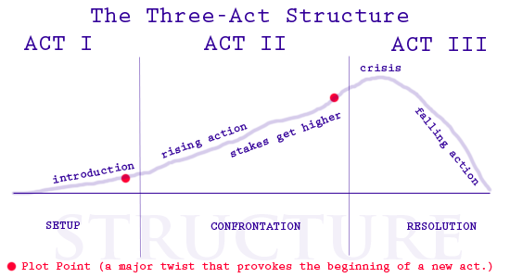

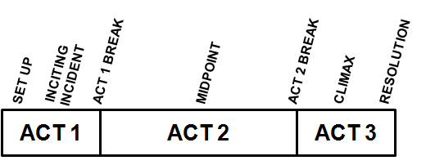

Three acts. Beginning, middle and end.
The beginning includes the set-up, inciting incident and Act 1 break.
The set up is just what it sounds like, an introduction to the setting and the characters.
The inciting incident is the spark that disrupts the status quo and kick-starts the story. In TOY STORY, this is Buzz Lightyear showing up. In ALIENS, this is Burke telling Ripley they’re going in to investigate the alien planet. In KNOCKED UP, this is Alison getting knocked up.
The Act 1 break is the scene when the protagonist decides to take action and enters a new world (to him).
Act 2 seems barren in the classic paradigm, but it’s characterized by rising action. This is the bulk of the story, the hero fighting to get what he wants.
The midpoint, which usually comes halfway through the story, is usually a high point. A false victory. Things seem pretty good for the hero here, but it quickly falls apart in the second half of Act 2.
The Act 2 break shows the hero rallying when things seem their bleakest. He’s going to give one final effort to win.
Act 3 is usually the shortest. It is the denouement, the climax of the action.
The climax is the final showdown between the hero and villain. It should be the most exciting part of the story.
The resolution is typically very short. A little coda to let us know how things turn out when the dust settles.
We’ll send a lot more time analyzing each of these steps in upcoming posts, but you’re probably not surprised at this point. This all makes sense. But why?
To answer that, we need to look at what’s going on under the surface of these seven key steps.
AN EMOTIONAL ROLLERCOASTER
Movies are catharsis machines.
Unlike fiction which is psychological and focused on creating epiphanies, movies are emotional and designed to provide catharsis — or emotional release — for the audience. By walking the audience through the ups and downs and twists of a genuinely cathartic series of events, a movie gives the audience an emotional workout.
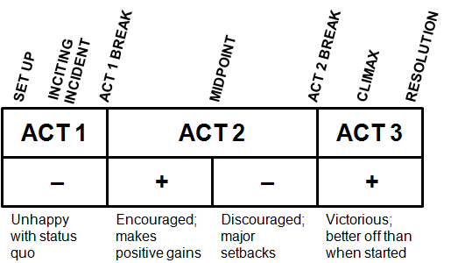
Let’s walk through the ups-and-downs of a traditional story:
In most movies, the hero begins somewhat unhappy with the status quo. Some gurus refer to this as the hero’s “need” and “desire”. Things may be generally good, but the hero wants something or has some problem. As such, he is in a negative state.
In the start of Act 2, the hero begins his quest and usually makes decent progress right out of the gate. This makes the hero happy. This continues until the false victory at the midpoint when the hero’s fortune changes.
In the second half of Act 2, the villain pushes harder and the hero encourages a number of major setbacks. So many (and each worse than the one before it) that by the end of Act 2, the hero is in shambles. Worse off than when he started. Maybe even close to dead.
In Act 3, the hero rallies, defeats the villain and emerges on top. In the end, he’s better off than when he started and the story ends on a positive note.
Put another way, the emotional charge of a movie is: Slightly negative … slightly positive … really negative … really positive.
If we were to map out the emotional charges in a movie, the graph would look something like this:
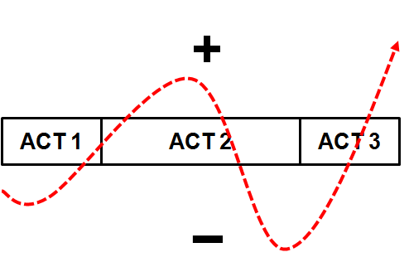HOW TO MOVE YOUR AUDIENCE
Three act structure is an equation for creating a strong emotional reaction in an audience:
- The story opens with on a slight negative to grab our attention and sympathies.
- The story swings to a positive to reward our sympathies and lower our guards. This also accentuates the upcoming drop.
- The story plummets to a very negative state. Now we’re really hooked because we’ve already invested in the hero’s worth and success. We’re also nervous because we’re not sure how it will be resolved.
- The story ends with a rise to new heights, leaving us happy, relieved and satisfied.
If the equation were shorter — just negative to positive — we wouldn’t be as engaged.
If the equation were longer, with additional major ups-and-downs, it could become repetitive (and less effective). Like tuning out a drama queen, we’d distance ourselves from the emotions in the story.
The three act structure, though, is long enough to be engaging but short enough to be effective. (And one reason it works so powerfully in film is that a feature-length movie is long enough to immerse yourself in but short enough to consume in one sitting.)
Another advantage to this equation is that while real life is complicated, a three act plot is simplified enough to be understandable and resolvable. At the same time, there’s (often) enough complexity for it to feel real and worthwhile. Finding that balance between complexity and simplicity is tricky, but it’s a lot easier when you’re building on the three act framework.

Mythologist Joseph Campbell looked at classic hero stories from various cultures and combined them into a common structure — the hero’s journey. This is a blueprint for a story so fundamentally human that it shows up in different cultures and times around the world.
The hero’s journey is about someone, sheltered in some way, who receives a call to adventure. This person must leave the comfort of the world he has always known and set forth on a dangerous quest. He gains allies and learns many things along the way. He faces many challenges and barely escapes death, all to gain some reward or insight. Once he has it, he becomes transformed. He must then hurry back to his home to share the reward with others.
Doesn’t that sound like the plot to more than a few movies?
The Terminator, written by James Cameron and Gale Anne Hurd.
Main Character: Sarah Conner
Catalyst: When the Terminator kills the first person named Sarah Connor. This is the moment when the danger to our hero is crystalized for the audience, though Sarah doesn't yet know about it. This sets up...

The Main Tension: Will Sarah survive the Terminator? Conflict is pure survival.
Act I : We set up the characters and their conflict. Act one ends when Sarah learns of the second killing and then spots Reese following her. She now realizes the danger she's in and begins looking for a way out - initially by seeking shelter in a night club and calling the police. (Very quickly she discovers that Reese is not the one she has to be afraid of.)
Act 2 Things get worse and worse for our hero. The act 2 Midpoint: When Sarah and Reese escape the attack in the police station. This is a crucial moment because it is when Sarah finally decides to trust Reese. She went along with him earlier, but she didn't really have any other good options then. It is here where she becomes convinced he's telling the truth... and that he's the only one who can help her. This is demonstrated when she's hiding under the desk, hears his voice and identifies herself to him.
Act 2 ends when the Terminator locates them at the hotel. Arguably you could point to the earlier moment when Sarah gives her "mother" her location because that is when the Terminator gets the information he needs to track them. But there is some time where the threat does not seem imminent - in fact we get the big love scene after this point. It still seems possible Sarah and Reese can avoid detection until the Terminator actually arrives.
Act 3 Resolution: Terminator finds their location and zooms off to kill them. They escape and Sarah has final confrontation with the Terminator and destroys the Terminator with the compactor. The main tension is resolved - our character has succeeded.
Twist/Epiphany: This one is tough. It has to do with Sarah taking charge of the action. I would put it at the moment when Kyle collapses and she yells at him: "on your feet, soldier!" You could also make a strong case for the moment he dies.

Cassablanca
1. INCITING INCIDENT
Ugarte (Peter Lorre) comes to Rick's Café Américain, a swank nightclub owned by American expatriate Rick Blaine (Humphrey Bogart), with letters of transit he obtained by killing two German couriers. The papers allow the bearer to travel freely around German-controlled Europe, and Ugarte plans to sell the documents to the highest bidder but leaves the letters with Rick for safekeeping. (00:10:15)
2. LOCK IN (End of Act One)
Even though Ugarte is captured by Captain Louis Renault (Claude Rains), a corrupt police official accommodating the Nazis, before he can sell the letters of transit to Victor Laszlo (Paul Henreid), a infamous Czech Resistance leader, Rick isn't locked in until Ilsa (Ingrid Bergman), Victor's wife and Rick's past lover in Paris, who re-enters Rick's life. (00:31:16)
3. FIRST CULMINATION (Midpoint)
Laszlo and Ilsa seek out Signor Ferrari (Sydney Greenstreet), one of Rick's competitor's and owner of a club called The Blue Parrot. Ferrari; however, his is only able to secure one exit visa for Ilsa, explaining that "it would take a miracle" to get Laszlo out of Casablanca. But the couple agrees that they are "only interested in two visas". Ferrari then hints that Rick has possession of Ugarte's letters of transit. (00:58:30)
4. MAIN CULMINATION (End of Act Two)
Ilsa confronts Rick in the deserted café, holding a gun on him in a desperate attempt to retrieve the letters of transit, but Rick dares her to "Go ahead and shoot." Unable to pull the trigger, Ilsa confesses that she still loves him, and only after this confession does Rick decide to help Laszlo escape Casablanca, leading Ilsa to believe that she will stay behind with Rick when Laszlo leaves. (01:21:19)
5. THIRD ACT TWIST
After Laszlo is jailed on a minor charge, Rick convinces Renault to release Laszlo, promising to set him up for a much more serious crime: possession of the letters of transit, However, Rick double crosses Renault, forcing him at gunpoint to assist in the escape. There is a final twist upon the twist, however, when at the last moment, Rick makes Ilsa get on the plane to Lisbon with her husband. (1:33:10)

THE FORCE BEHIND STAR WARS
George Lucas was a big fan of Joseph Campbell. He used Campbell’s hero’s journey as the spine for STAR WARS, and it’s one of the reasons that movie continues to delight today even though the special effects are long since dated. THE MATRIX follows the same blueprint, as does THE LORD OF THE RINGS and TERMINATOR 2.
Clearly, the hero’s journey is worth a closer look.
To learn more, you can read Campbell’s book, which I highly recommend. Screenwriting guru Christopher Vogler wrote an analysis of the hero’s journey for screenwriters called The Writer’s Journey. To get us going, there’s a summary of the hero’s journey from Vogler’s book’s Wikipedia page. Here it is:
1. THE ORDINARY WORLD. The hero, uneasy, uncomfortable or unaware, is introduced sympathetically so the audience can identify with the situation or dilemma. The hero is shown against a background of environment, heredity, and personal history. Some kind of polarity in the hero’s life is pulling in different directions and causing stress.
2. THE CALL TO ADVENTURE. Something shakes up the situation, either from external pressures or from something rising up from deep within, so the hero must face the beginnings of change.
3. REFUSAL OF THE CALL. The hero feels the fear of the unknown and tries to turn away from the adventure, however briefly. Alternately, another character may express the uncertainty and danger ahead.
4. MEETING WITH THE MENTOR. The hero comes across a seasoned traveler of the worlds who gives him or her training, equipment, or advice that will help on the journey. Or the hero reaches within to a source of courage and wisdom.
5. CROSSING THE THRESHOLD. At the end of Act One, the hero commits to leaving the Ordinary World and entering a new region or condition with unfamiliar rules and values.
6. TESTS, ALLIES AND ENEMIES. The hero is tested and sorts out allegiances in the Special World.
7. Approach The hero has hit setbacks during tests & may need to try a new idea.
8. THE ORDEAL. Near the middle of the story, the hero enters a central space in the Special World and confronts death or faces his or her greatest fear. Out of the moment of death comes a new life.
9. THE REWARD. The hero takes possession of the treasure won by facing death. There may be celebration, but there is also danger of losing the treasure again.
10. THE ROAD BACK. About three-fourths of the way through the story, the hero is driven to complete the adventure, leaving the Special World to be sure the treasure is brought home. Often a chase scene signals the urgency and danger of the mission.
11. THE RESURRECTION. At the climax, the hero is severely tested once more on the threshold of home. He or she is purified by a last sacrifice, another moment of death and rebirth, but on a higher and more complete level. By the hero’s action, the polarities that were in conflict at the beginning are finally resolved.
12. RETURN WITH THE ELIXIR. The hero returns home or continues the journey, bearing some element of the treasure that has the power to transform the world as the hero has been transformed.

LET’S LOOK AT AN EXAMPLE: TERMINATOR 2
Part of the strength of TERMINATOR 2 is that both the Terminator and John Conner complete the hero’s journey…
1. THE ORDINARY WORLD. We open with the T-800 traveling through time on his mission to find and protect John Conner. Rough and tumble and not worried about killing people. Then we meet John Conner, a rebellious youth living in a foster home.
2. THE CALL TO ADVENTURE. The arrival of the T-1000 shakes up the situation and forces both the T-800 and John to act.
3. REFUSAL OF THE CALL. John sees the T-800 and runs. He doesn’t want to face his destiny.
4. MEETING WITH THE MENTOR. Interestingly, the T-800 and John mentor each other.
5. CROSSING THE THRESHOLD. John accepts the facts of the situation and orders the T-800 to help him rescue Sarah Conner, John’s mom.
6. TESTS, ALLIES AND ENEMIES. The T-800′s new “no killing” rules are tested as the rescue Sarah.
7. APPROACH TO THE IN-MOST CAVE. John and the T-800 continue to learn from each other. They travel to Sarah’s secret cache of weapons.
8. THE ORDEAL. They save Miles Dyson, introduce him to the Terminator and show him the light.
9. THE REWARD. The treasure, in this story, is the chip and robotic arm Dyson keeps in the Teledyne office. They steal it to prevent Skynet from being created.
10. THE ROAD BACK. The police and T-1000 show up and the famous semi chase to the steel works begins.
11. THE RESURRECTION. The hero’s are tested in their fight against the T-1000. As a last sacrifice, they must destroy the T-800, robotic arm and chip.
12. RETURN WITH THE ELIXIR. John and Sarah set out on the road, transformed and ready to fight.
THE HERO’S JOURNEY OR THREE ACT STRUCTURE?
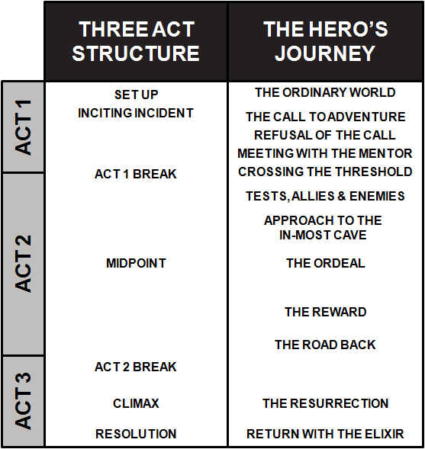

Chekov’s Rule: "If in the first act you have hung a pistol on the wall, then in a following act it should be fired. Otherwise don't put it there."
Plato’s Poetics
According to Aristotle, there is a hierarchy of six dramatic elements that should be applied to the successful ‘drama’, and that when these are fully realized, ‘your screenplay will sing!’ These elements are:
- plot,
- character,
- thought (theme),
- diction (language),
- music (sound) and
- spectacle (visual language)
According to Aristotle, the ability to plot, or to create a powerful structure, is the most important aspect of writing. Although these elements have evolved very little in the past 2000 years, I would argue that Aristotle’s assertion that plot needs to be at the top of the hierarchy is somewhat dated, and that the contemporary writer needs to be more flexible in these hierarchical elements in order meet the demands of an ever-changing market.
Drama, as Alfred Hitchcock reminds us, is life with the boring bits cut out. Writers therefore need to ‘…organize the chaos of life into something meaningful, something that is cast so precisely that when it is struck, it rings of poetic, artistic truth.’ In order to fulfill that requirement we need strong characters to do the work, for the plot will not drive itself.
In asserting the significance of character, however, we must not sideline the importance of the plot. Aristotle tells us that the plot should be so tight, that if you took away any one incident, the whole would collapse:
“The plot should have] its several incidents so closely connected that the transposal or withdrawal of any of them will disjoin and dislocate the whole. For that which makes no perceptible difference by its presence or absence is no real part of the whole.”
It is through the resolution of the hero’s moral conflict in the denouement that the ‘theme’ of the movie is stated. The theme reveals a truth about the human condition that has been demonstrated by the story’s action.
Another way to develop your story is to use a step outline or a master scene list…All these scenes should be essential to furthering the story. Each should have a raison d’être, and there should be some change in the status quo by the end of every scene.
When the writer’s hand becomes visible in its efforts to cover gaping holes, and as a result we see action or hear dialogue which does not fit into the story’s scheme or is inconsistent with the characters as established, we are taken out of the story and the script has failed.
In creating a real human being for an audience, it is important to have them do and say things that convince the audience that they are alive.
Dialogue is part of the action and gets its power from the plot, whose effect builds in a cumulative as well as linear way. Dialogue forms story action and derives life and energy from the action it helps build. This is a symbiotic relationship.
It is also important to have symbiosis between character and diction.
The penultimate element in Aristotle’s hierarchy is music or ‘sound’. Sound, or indeed silence, can be used to enhance the mood of a piece, and is a great device for ‘showing not telling.’ Instead of ‘writing what you know’, Aristotle pleads with his reader to ‘write what you truly feel, or truly experience in your heart.’
Through ‘catharsis’, (purging of emotion) the audience releases not just the emotions the movie has stirred up in them, but they also dump other psychic garbage they’ve been carrying around. Catharsis leaves the audience with a renewed sense of mental clarity and better able to function in life. According to Aristotle, catharsis works best if everything in the story builds towards creating this one experience.
According to Aristotle, the least important element in the hierarchy is spectacle. I would argue, however, that, in screenwriting, it is of greater importance. Films need to be extremely visual in order to work – although that doesn’t mean excessive use of special effects. Use of location and precise physical action can be just as visually stimulating

Aristotle uses the word tragedy to mean serious drama and comedy to mean stories about fools and low class people. Comedy was not to be taken seriously.
Some more observations from Aristotle:
- Say what the story demands
- Back story – things that happen before the story begins. A prologue is a way to connect the back story with the main story. It can set the stage for the inciting incident.
- The beginning of the story (first act) should contain the inciting incident (in the Godfather, this is when Don Corleone refuses to become partners with Sollozzo)
- “A tragedy is an imitation of a serious action, one having magnitude”. You have to choose which parts of life to put in and which parts to leave out.
- Aristotle thought plot was of primary importance. The plot must have dramatic unity. The story should be about one thing. That is why stories that cover long periods of time may go astray – they are about individual episodes, for example as in a true life biography.
- All cause and effect relations must be either probably or necessary. Incidents of necessity always happen after a given cause of action, and therefore propel the story forward. Probable dramatic incidents are likely to occur, but also propel the story. For example, when Rock is training for the big fight, Mickey begs to be his manager. This was not necessary. Some stories use more probable incidents than necessary incidents, and the story seems looser. According to Aristotle, the entire chain of the plot must form a story that is composed of either probable or necessary events.
- The perfect plot must have a single focus, and the organic unity of a living creature
- Reversal. A reversal takes place when a key action designed to produce one result actually leads to its opposite. Aristotle's example is when the messenger comes to Oedipus to alleviate his worries, but in the act of revelation actually discloses the information that will lead to Oedipus's downfall.
- Recognition. Recognition involves the change from ignorance to understanding, and the ultimate climax of a tragedy comes when recognition and reversal coincide. The best forms of recognition are linked with a reversal (as in Oedipus) and, in tandem, will produce pity and fear from the audience.
- Catharsis is pity for the hero, and fear that his fate could befall us. While pity is the result of any combination of reversal and recognition, fear can only be a product of reversal and recognition crafted into a surprising ending to the plot. And indeed, the absolute pinnacle of tragedy comes when surprise, reversal, recognition, and suffering are united around the core spine of the story in a swift blow to the audience at the end of the third act. In Titanic, Jack suffers emotionally and physically to save Rose. Then Rose dies in her sleep, dreaming of Jack and the audience releases their burden of pity and fear.
- Four types of plot according to Aristotle:
  - Complex – containing both Recognition and Reversal. Angel Heart, Rosemary’s Baby, Planet of the Apes (the original)
  - Tragedy of Suffering – Ingmar Bergman movies
  - Tragedy of Character – stories more interested in developing characters.
  - Spectacle – big visuals, costumes, scenery, special effects.
- The protagonist must make choices in act one that create the conflict and lead to the resolution in act three. In the Gladiator, Maximus refuses to recognize Commodus, who has murdered his father, and stolen his crown. This is sometimes called the fatal flaw: pride is an example.
- Moral turmoil arises from a central moral question. Michael in the Godfather: follow the family business or his own?
- A story should be as long as it needs to be and no longer.
- A plot must include causes of the action that can arouse the audience’s pity and fear. This means the audience must understand the hero’s thoughts and see those thoughts become actions, which in t urn reveal a moral quality of the hero. This helps the audience to relate to the hero and feel empathy.
- A Chorus can provide commentary on the action. For example, in the Terminator, the shrink and the cops provide commentary (horribly incorrect as it turns out) on the action so far. Since we know they are totally wrong, we buy into the reality of the Terminator’s mission and the importance of Reese saving Sarah.
- Four components of a good character:
  - They should be good enough for people to empathize with.
  - They should be appropriate, they should have characteristics appropriate for the type of person they are.
  - Give them flaws or quirks
  - Be consistent with a through c.

Story structure according to Dan Harmon, creator of Community:
Storytelling comes naturally to humans, but since we live in an unnatural world, we sometimes need a little help doing what we'd naturally do.
Draw a circle and divide it in half vertically.
Divide the circle again horizontally.
Starting from the 12 o clock position and going clockwise, number the 4 points where the lines cross the circle: 1, 3, 5 and 7.
Number the quarter-sections themselves 2, 4, 6 and 8.
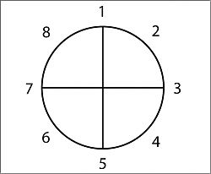

Here we go, down and dirty:
- A character is in a zone of comfort,
- But they want something.
- They enter an unfamiliar situation,
- Adapt to it,
- Get what they wanted,
- Pay a heavy price for it,
- Then return to their familiar situation,
- Having changed.
Start thinking of as many of your favorite movies as you can, and see if they apply to this pattern. Now think of your favorite party anecdotes, your most vivid dreams, fairy tales, and listen to a popular song (the music, not necessarily the lyrics). Get used to the idea that stories follow that pattern of descent and return, diving and emerging. Demystify it. See it everywhere. Realize that it's hardwired into your nervous system, and trust that in a vacuum, raised by wolves, your stories would follow this pattern.

Here are those steps from tutorial 101 again, boiled down to the barest minimum I can manage while still speaking English:
- When you
- have a need,
- you go somewhere,
- search for it,
- find it,
- take it,
- then return
- and change things.
Less focus on English, more on importance:
- You
- Need
- Go
- Search
- Find
- Take
- Return
- CHANGE
Sounds like a caveman giving you an order. That's what it is. Behind (and beneath) your culture creating forebrain, there is an older, simpler monkey brain with a lot less to say and a much louder voice. One of the few things it's telling you, over and over again, is that you need to go search, find, take and return with change. Why? Because that is how the human animal has kept from going extinct, it's how human societies keep from collapsing and how you keep from walking into McDonald's with a machine gun.
If you were hired to write a script for a race of super-evolved spiders, you might find that they prefer a more linear model. In the spider version of Jack and the Beanstalk, Jack might build his own beanstalk, find a sandwich at the top of it, eat some and save some for later. The End. That's not really inspiring to us. We like us some circles. We like big ones, we like little ones, and given the choice, we'll take a shitty one over a lack of one, but, unless you're writing for some other species, it will pay for you to keep things fairly round.
Jack goes up the beanstalk, Jack finds some cool shit, Jack steals it, runs back down, and gives it to his Mom.
We need go search- We need get fire, we need good woman, we need land moon- but most importantly, we need RETURN and we need CHANGE, because we are a community, and if our heroes just climbed beanstalks and never came down, we wouldn't have survived our first ice age.

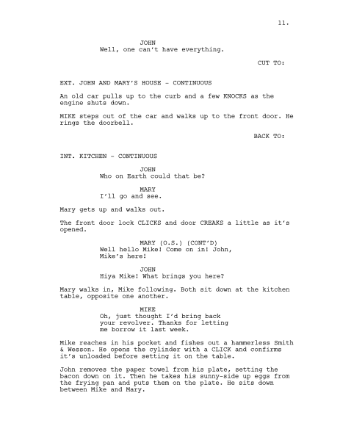

A great lecture on screen writing by Stephen J Cannell: http://www.writerswrite.com/screenwriting/lecture.htm

Another good explanation of the 3 act story
http://www.elementsofcinema.com/screenwriting/3-act-structure.html

An argument in favor of a 5 act story structure, by someone claiming to be called Hulk, and written in Hulk style prose. If you can get past the tortured syntax, the argument is pretty interesting
http://filmcrithulk.wordpress.com/2011/07/07/hulk-presents-the-myth-of-3-act-structure/

More from Hulk, this time a guide to screen writing:
http://badassdigest.com/2012/01/12/screenwriting-101-1-of-2/
And part two of the same essay:
http://badassdigest.com/2012/01/12/screenwriting-101-2-of-2/

An amazingly funny review of the story failures of the new Star Wars movie. Here is the first of 7 parts, the other parts can be found on You Tube:
http://www.youtube.com/watch?v=FxKtZmQgxrI

Same guy reviews Avatar
http://www.youtube.com/watch?v=uJarz7BYnHA&feature=relmfu

