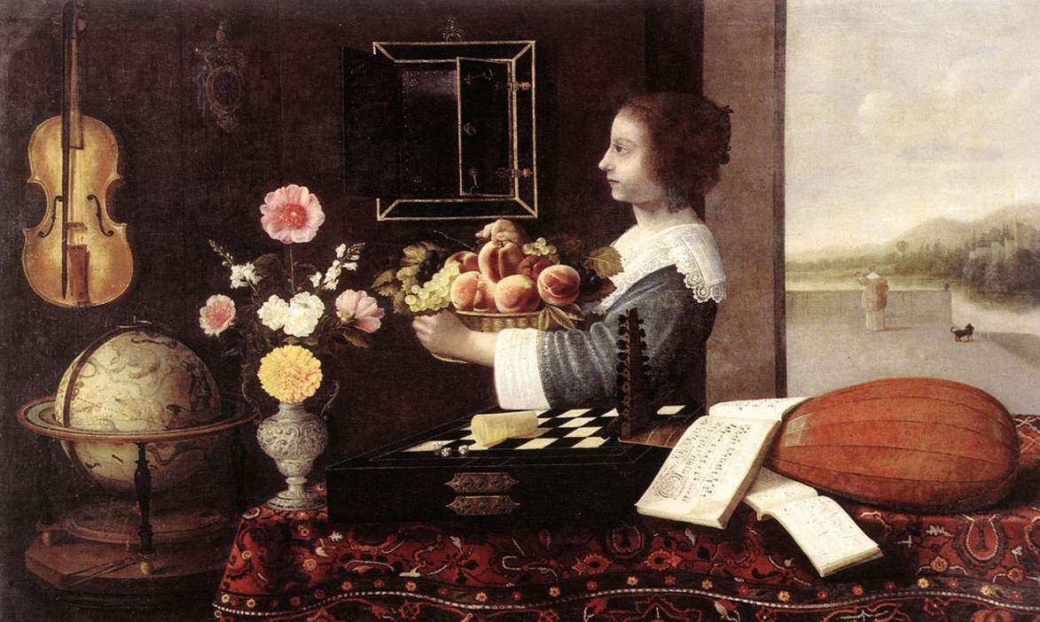

What is the theme of this picture? Think in terms of WoKs.

Sensory information and interpretation

I cdnoult blveiee that I cluod aulaclty uesdnatnrd waht I was rdanieg. The phaonmeal pweor of the mmid. Aoccdrnig to a rscheearch at Cmabridge Uinervitisy, it dnesot mttaer in waht oedrr the ltteers in a wrod are, the olny iprmoatnt tihng is taht is taht the frist and lsat lteer be in the rghit pclae. The rset can be a taotle mses and you can sltil raed it wouthit a porbelm. This is bcuseae the huamn mmid deos not raed ervey lteter by istlef, but the wrod as a wolhe. Amzanig! I awlyas thought slpeling was ipmorantt.

According to Gestalt theory, we tend to perceive objects visually as meaningful patterns or groups rather than as separate parts.
John Locke distinguished between primary and secondary characteristics. Primary characteristics are inseparable from objects and would be perceived in the same way by everyone. Secondary characteristics are characteristics that are not inherent in the object itself, but are attributed to the objects by our sensory perception. Secondary characteristics only exist in the mind of the observer.
Classify the following:
- Density B) Taste C) Size D) Smell E) Number F) Shape G) Color H) Sound

Human Sensory Perception

Stimuli | Sense Receptors | Sensation | Response (example of meaning attributed)
Electromagnetic energy(EM) between 400nm and 700nm | Eyes, retina | Light and color. EM radiation reflecting on an object results in visual perception | I can see the chair
Vibrations or waves with a frequency between 20 and 20,000 HZ | Ear, auditory nerve | Sound. | That is my favorite song
Odor molecules | Nose, olfactory receptor neurons | Small. Combinations of molecules result in the perception of smell | I love the smell of Napalm in the morning
Chemical compositions | Mouth, taste buds, chemoreceptor cells | Sweet, sour, salty and bitter. | This cookie tastes good
Pressure, temperature | Skin, nerve endings | Hot, cold, texture, pressure, pain | That cup of coffee is hot
Others?

What might you perceive that other people might not? Example: fish, Matrix
How can you tell if your ability to perceive is normal? How is normal defined?
Assignment: Investigate animal senses that are different from the five common senses of sight, hearing, smell, touch and taste. For example, the lateral line system of fish for sensing pressure, echolocation and barometric sensitivity of bats, use of a tongue by snakes to smell or their sensitivity to vibration, electrosensing of sharks, chemo-receptors on the entire bodies of earthworms. Drawing on the information you collect, choose any one animal and be prepared to enter imaginatively into its sensory world. For class on Monday, October 1 have a description of how the animal you chose perceives the computer lab. Each student will read their description aloud and the class will try to guess which animal was chosen.
Here is a TED talk by Beau Lotto about sensory perception: http://www.youtube.com/watch?v=mf5otGNbkuc
Some of the most interesting observations from this video are: 1) there is no inherent meaning in information. Our minds create meaning. 2) Our brains did not evolve to see the world as it is. Our brains evolved to see the world in ways that increased our odds of survival. 3) each of us is defined by our ecology and our ecology is relative, historical and empirical.
Consider these questions:
- Can you believe your eyes?
- What does Lotto mean when he says that the things we see all depend on context?
- How does evolution help us to make sense of these ideas?
- What are the implications of Lotto’s ideas?

Go to this web site and look at the optical illusions. Pick one or two that you like and comment on them in the ToK Blog page. Due Monday, October 1. Look at the Dancer. Can you see her change directions? Look at the Neeker cube. At some point it will change orientation in your mind.

Look at the Kanizsa triangle (third row, far right). What shape is being described?
Loos at the Sphere Size illusion. Which sphere appears larger and why? Why might our brains have evolved this way?

Visual illusions
Look through these visual illusions on YouTube.
- What do visual illusions reveal about the reliability of sight?
- Does this mean that we should doubt all the knowledge acquired through the senses
- Check out a few of these stereograms: http://www.eyetricks.com/3dstereo.htm
Can you see the hidden images?
Watch this video on forced perspective: http://www.youtube.com/watch?v=bZYh_HRY70g
http://www.gtack.com/p.php?p=7ywux4c7&s=3

Investigate Esref Armagan. He was born without sight, yet he can paint recognizable pictures.

Sense perception knowledge issues and links with other WOKs and AOKs
400 word essay on one of the following topics:
1) In what ways does the biological constitution of a living organism determine, influence or limit its sense perception? If humans are sensitive only to a certain range of stimuli, what consequences or limitations might this have for the acquisition of knowledge? How does technology extend, modify, improve or restrict the capabilities of the senses?
2) Is the nature of sense perception such that, as Huxley suggests, sensations are essentially private and incommunicable?
By its very nature every embodied spirit is doomed to suffer and enjoy in solitude. Sensations, feelings, insights, fancies-all these are private and, except through symbols and at second hand, incommunicable.
Aldous Huxley (1954)
3) What is the role of culture and language in the perceptual process? Given the partially subjective nature of sense perception, how can different knowers ever agree on what is perceived? Do people with different cultural or linguistic backgrounds live, in some sense, in different worlds?
4) It is often claimed that information and communication technologies are blurring the traditional distinctions between simulation and reality. Is this the case? What could be the consequences?
5) To what extent is reason based on previous sensory experience?
6) Which senses are most important in our interaction with the arts?
7) Are natural sciences limited in reliability by the extent to which our senses observe scientific experiments accurately?
8) How is our understanding of language similar to the way we perceive reality with our senses?

