TOK Language
Ten words that do not translate into English:
http://www.youtube.com/watch?v=g_5sN0dbRh4&feature=g-vrec

1. Language starting points
If you knew sign language, you’d be pretty pleased to see this
The importance of language is obvious. It is, in other words, where we begin when we try to understand a concept. But it’s hard to know the exact boundaries of what we mean when we refer to ‘language’. Are we talking here of written, oral, or all forms of communication? Love, for example, is sometimes described as the universal language; music has been described similarly. So what are we actually talking about?
The OED defines language as:
• noun 1 the method of human communication, either spoken or written, consisting of the use of words in a structured and conventional way. 2 the system of communication used by a particular community or country. 3 the phraseology and vocabulary of a particular group: legal language. 4 the manner or style of a piece of writing or speech. 5 Computing a system of symbols and rules for writing programs or algorithms.
- - ORIGIN Old French language, from Latin lingua ‘tongue’.

This fits in pretty well with what we take language to be in theory of knowledge: human communication, either spoken or written. Having said that, we will not only try to consider what part these aspects play in how we acquire knowledge, we will also try to think about other forms of communication that are not written or spoken, since there are so many of them.
Questions we need to think about, amongst other things, are how human beings first acquired language, how language shapes the way we think, and whether language assists or limits us as we search for knowledge.

2. How did language evolve?
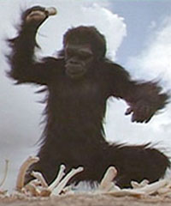Do actions speak louder than words when it comes to communication?
Human language can be divided into two types: natural languages and constructed languages. The former are our ‘native’ languages, the ones we learn to speak from an early age (in fact, a new study has suggested we begin to learn before we are even born – see later notes), and which have evolved over a period of many centuries into their present form. The latter are languages that have not evolved over a long period of time, and have been ‘made up’ by humans. They include computer programming languages, and new languages such as Esperanto. In TOK, we are primarily interested in natural languages, though we must not overlook the second form of communication entirely.

When did humans first start to talk?
Unfortunately, we don’t know for sure when language was first used. Estimates vary wildly from the time of Homo habilis 2,000,000 years ago, to the time of Cro-Magnon man around 30,000 years ago. For obvious reasons, it’s very hard to know for sure when human beings (or earlier forms of our species) first started talking to one another – unlike dating the first time writing was used. There is some sort of consensus, however, that spoken communication was definitely being employed approximately 50,000 years ago at about the point when humans began to disperse from Africa, and move to other regions around the globe.
Since then, different forms of language began to evolve, and today there are around 7000 different languages being spoken by the 7 billion or so of the world’s population. Many of these can be grouped together into a language family, based on similarities in such elements as vocabulary, grammar, and pronunciation. Examples of language families are the Indo European languages, spoken by around 3 billion people (including English, Spanish, Hindi, and Urdu), the Afroasiatic languages, spoken by about 350 million people (including Arabic and Hebrew), and the Sino-Tibetan languages, spoken by around 1.5 billion people (including Cantonese, and Burmese). There is a great deal of debate over the taxonomy of language, and what should be the basis for organizing languages into different families.
To give some idea of the complexity of the issue, the following diagram shows the ‘family tree’ of the Indo-European family tracing all the languages back to a common ancestor.
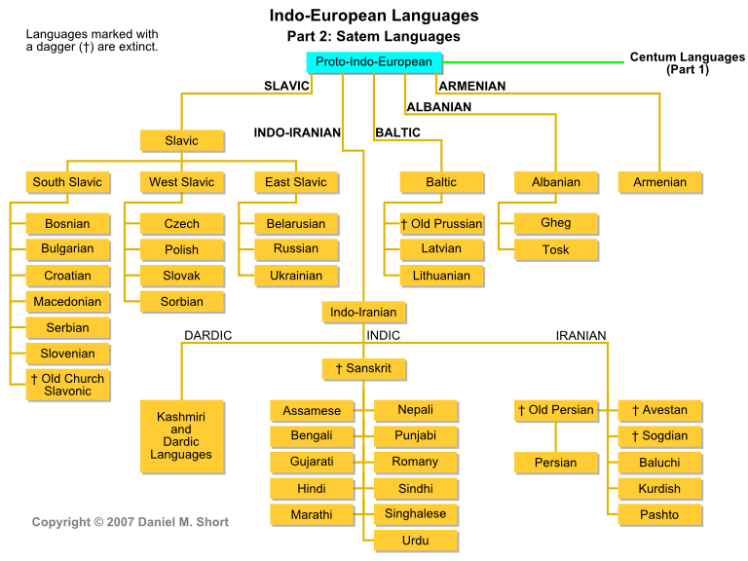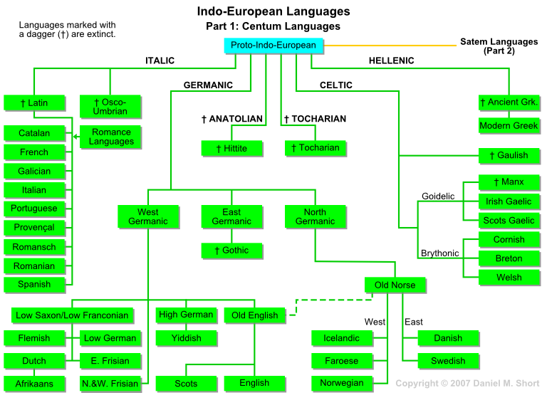

Why did humans start to talk?
The first thing to think about here is that in order to talk, you need, to possess the physiological ability to talk. Critical in human language is the fact that our larynx is situated relatively far down our throat, which means that our vocal tract is much longer than in other animals, allowing us a much wider range when it comes to articulating noises. Think about the string on a musical instrument: if it is very short, there’s not much you can do with it; a longer one, however, is more versatile, according to where you pluck it.
Some linguists have argued that it was the evolution of this descended larynx that led to humans first developing language, though it’s no easy guess to make in saying when that occurred. Critics have also pointed out that the descended larynx also exists in many aquatic mammals and large deer, and although Bambi did speak in the Walt Disney film, you don’t often hear the average monkjack doing the same in the wild.

The reason for language?
The British anthropologist Roger Lewin has suggested that new technology used by humans, such as stone tools used to hunt, was one of the ‘driving forces’ in the evolution of the brain. In other words, there was a need to name and label the different tools and the methods used to construct them, and this need occurred at the same as the brain was enlarging.
Another possible cause – acknowledged by Lewin along with other anthropologists – is that language arose out of a more complex social world, where relationships and interactions were becoming more sophisticated than the proverbial bash over the head with a club, and the future wife dragged into the cave.
Of course, there is no reason why all these reasons together could not be the reason for the appearance of language. As Stephen Pinker, the famous cognitive psychologist as Harvard puts it: ‘this triad – language, social cooperation and technological know-how is what makes humans unusual. And they probably evolved in tandem, each of them multiplying the value of the other two.’

Questioning the relationship between us and language: The Edinburgh University Evolution Experiment
The assumption so far is that language was invented by humans, then developed as our need for more complexity has increased. Our brains, in turn, have adapted to be good at learning language. A different approach has been taken by researchers at Edinburgh University, who are examining the theory that it is language that has done the adapting – rather than our brains - to be easily learned by us.
In the words of the research team:
‘Language, because it is culturally transmitted, is an evolutionary system in its own right. Many of the adaptive features of linguistic structure arise from this process rather than having to be encoded specifically in our genes. Of course, the human brain provides the essential scaffolding for the cultural evolution of language in the first place, but it need not specify all the details innately.’

3. How do we learn languages?
Getting grammar right in another language is sometimes tricky
One of the biggest questions over human behavior is whether our actions are determined by our natures, or by our nurtures. In other words, do we act the way we do because of genetic programming – innate qualities that we have no power over – or is it the way we are brought up, treated, educated, and so forth. This will be discussed in more detail in human sciences, but the debate interests us in language in the question over how we learn to speak. Is it an innate human capacity, or is it purely a result of our environment, as we first imitate our parents and family members, and then apply the rules of grammar to perfect our powers of communication?

Human versus animal language
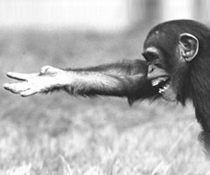
He’s definitely saying something

First, it’s perhaps useful to distinguish human from animal language. Clearly, what is innate to all of us – something we share with most animal life-forms – is the instinct for communication. As soon as we are born, we know how to communicate, and generally do so as soon as we exit the womb by giving a startling cry that announces our arrival in the world. We are at this point communicating our needs to our mother, the result of a combination of feelings, including fear, hunger and pain.
Most animals share this most deep-rooted of instincts to ‘talk’ to our mother. Furthermore, many animals are able to communicate surprisingly sophisticatedly, and stories of chimpanzees being taught how to express themselves are proverbial (check out this link a story by the Skeptic Society for one such example: http://www.skeptic.com/eskeptic/07-10-31
But clearly, humans go far beyond this inarticulate (though not ineffective) wailing, and very soon are able to string sophisticated sentences together to vividly express what we are thinking, and what we require. Where, however, is the line between what we can do and what animals can do? What separates the way we communicate with sounds to the way animals do?
Here are four suggestions for what separates human from animal language:
- Arbitrariness: Most words are a collection of letters that have no rational relationship with what they represent, instead, they are arbitrary. In other words, there is nothing in the word ‘tree’ that has any inherently ‘tree’ qualities about it.
- Reordering: Language is made up of different units (ie letters, words, phrases, etc.) that can be broken down and reordered to create different meaning. These units are finite, but their possibilities are effectively infinite.
- Abstractness: Human language can express and describe concepts that are not based on objects in the immediate vicinity.
- Metalinguistic: Language can be used to describe itself.

Language acquisition
But are these four characteristics ‘natural’ to us, or do we have to learn them? Once again, this is a question with no easy answer.
Our opinion on this huge question has changed constantly through history. Plato believed that our capacity to use language was innate.
Empirical thinkers such as John Locke felt believed that we begin as ‘blank slates’, so there was no innate ability in this respect.
This position was challenged by nativist thinkers (such as Noam Chomsky and Stephen Pinker) who believe that certain skills and abilities – such as language learning – are ‘hardwired’ into the brain.
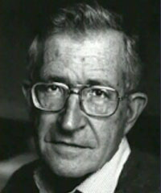Noam Chomsky
Modern theories include the Rational Frame Theory, developed by Steven C. Hayes and Dermot Barnes-Holmes. This is based on the work of B.F. Skinner’s Behaviourist ideas, and posits the idea that our language acquisition is purely a result of our interaction with the environment.
Finally, the Competition model of language acquisition, proposed by Elizabeth Bates and Brian MacWhinney, argues that neither nature nor nurture alone is sufficient in the process of acquiring a language. Instead, innate cognitive functions are activated by interacting with the environment, allowing us to build up our language abilities.
Where you stand, in other words, depends on your philosophical standpoint, because the evidence is inconclusive either way.
One argument that we must have some innate language-learning skills points out that although children learn between 10 and 15 new words every day, only one of these can be accounted for by direct experience. Noam Chomsky gives a great deal more evidence, saying that almost every sentence that we speak is a brand new combination of words that has never before appeared. To be able to create something like that, the brain must have some kind of program enabling it to create infinite combinations out of finite resources (ie lists of words).
Those who say that the environment is the more important ingredient in the process merely point out the effective of direct teaching upon children – especially when it comes to second language acquisition.

When do we begin acquiring our language?
New research has suggested that we begin learning languages even before we are born. In a international study carried out by German researchers, babies’ cries were found to be made in the same accent as the language their mothers spoke.
This story can be found by going to http://news.bbc.co.uk/2/hi/health/8346058.stm

4. The extent of our language = the extent of our knowledge?
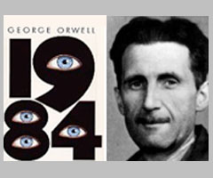

"And if all others accepted the lie which the Party imposed-if all records told the same tale-then the lie passed into history and became truth. 'Who controls the past' ran the Party slogan, 'controls the future: who controls the present controls the past.'"
- George Orwell, 1984, Book 1, Chapter 3

WAR IS PEACE
FREEDOM IS SLAVERY
IGNORANCE IS STRENGTH

It’s not possible to not draw on Orwell for this section
It comes from a conversation that Winston has with Syme, who is writing a new dictionary, although perhaps it is better to say editing the old dictionary by cutting away ‘superfluous’ words, and amalgamating others that mean the same. Syme explains the rationale of this to Winston:
‘'Don't you see that the whole aim of Newspeak is to narrow the range of thought? In the end we shall make thoughtcrime literally impossible, because there will be no words in which to express it. Every concept that can ever be needed, will be expressed by exactly one word, with its meaning rigidly defined and all its subsidiary meanings rubbed out and forgotten. Already, in the Eleventh Edition, we're not far from that point. But the process will still be continuing long after you and I are dead. Every year fewer and fewer words, and the range of consciousness always a little smaller. Even now, of course, there's no reason or excuse for committing thoughtcrime. It's merely a question of self-discipline, reality-control. But in the end there won't be any need even for that. The Revolution will be complete when the language is perfect. Newspeak is Ingsoc and Ingsoc is Newspeak,' he added with a sort of mystical satisfaction. 'Has it ever occurred to you, Winston, that by the year 2050, at the very latest, not a single human being will be alive who could understand such a conversation as we are having now?'’
The thinking here is clear: if we don’t have words for a concept or thing, then we cannot conceive of a concept or thing. It is one of the key knowledge issues inherent to language, and needs thinking about in some detail.

Linguistic relativity versus the universal language
An urban myth: Eskimos have a hundred words for what this is made of
One of Chomsky’s other theories, which fits in very well with his ideas of our innate abilities in language learning is that language is universal – that is to say, whatever tongue we speak in, we still perceive of the world in the same way. An alternative way of looking at language is termed linguistic relativism, which argues that different languages lead to different perceptions of reality, leading cultures to behave distinctly according to what words and phrases they use to label the world.
The linguistic relativity principle, also known as the Sapir-Whorf Hypothesis, after the two men who proposed and developed it, posits the idea that our understanding of the world depends to a large extent on the language with which we use to interact with it. For example, different words for different colors leads us to form different perceptions of the world, and in the most famous example, the Inuit people were said to have a multitude of different words for snow, allowing them to see it in a totally different way to those of us who don’t spend most of our lives in a snow bank.
This theory is most effective when one compares the languages of cultures that are very far removed – rather than just comparing the subtle differences between, say, Italian and French. One that has been studied in great depth is the Pirahã people of the Brazilian Amazon. They use three different words for numbers, that translate as ‘approximately one’, ‘a little more than one’, and ‘a lot more than one’. Since their whole perception of groups of objects is based on this, they have serious difficulties counting and distinguishing between patterns of objects once their numbers rise beyond about eight. Studies to investigate this were carried out by Peter Gordon of Colombia University, and his findings can be read in either Science Magazine or the Economist.
Although the Sapir Whorf hypothesis came under a great deal of attack by academics in the 1960s – the Inuit words for snow, for example, were discovered to have been massively inflated, due to a poor understanding of their language – it has gradually come back into favour, so that now many linguists accept that there is some difference of perception depending on the language that we use. Certainly there are many untranslatable terms that anchor certain concepts to certain languages and cultures – the German Schadenfreude, for example, the fact that so many culinary terms are French, or that musical directions are in Italian.

Euphemisms
What would you call him?
Euphemisms have long been used to change the impact of certain words, and make them more socially acceptable.
The most common term that is replaced with a euphemism is ‘toilet’: in most cultures we ask, instead, for directions somewhere else, leading us to the bathroom, restroom, W.C., or we simply reword our request to turn it into a desire to ‘powder our nose’.
Another taboo in society that is often covered up by euphemisms is death, and there are scores of phrases that can be used in its place that means the same thing: such as pushing up the daisies, passing on, and kicking the bucket.
Euphemisms are commonly employed by the authorities to make government policies more acceptable, or by groups seeking to either justify themselves, or rubbish their opponents. Or they are simply used to make someone or something feel more important. Here are a few examples, but there are many, many more out there:
- Collateral damage versus innocent loss of life
- Pro-life versus pro-choice
- Freedom fighters versus terrorists
- Secretary versus personal assistant
- Extermination versus liquidation or cleansing
- Euthanasia versus killing
- Taking one’s life versus suicide
- Bravery versus discretion
- Letting someone go versus firing

The two factor theory of emotion
The third view of how emotion works was put forward in the 1960s. It was based on an experiment carried out in 1962 by Stanley Schachter (1922-1997) and Jerome Singer, which saw 184 volunteers injected with either a saline solution or adrenaline. These volunteers were told that they were testing a new drug called Superoxin, and were told different things about what the side effects would be. Some were told they would experience increased heat beat and rapid breathing – the normal effects of adrenaline; some that they would feel a mild headache (which does not happen with adrenaline shots); and some that there would be no side-effects at all.
The volunteers were left in a room while the adrenaline kicked in. There, one of the experimenters pretended to be part of the test, and faked either an angry or a happy mood after being injected. The reaction of those waiting with this person was then recorded.
The results showed consistently that those who had been given a saline solution (which produces no effect) or that were incorrectly informed about the side effects of the adrenaline shot copied the reaction of the fake volunteer. Those who had been told of the correct effects of the adrenaline, however, experienced those effects, even when it meant behaving in a completely different way to the fake volunteer.
The conclusion that the researchers arrived at was that for the body to arrive at an emotional state, two factors were necessary (hence the name of the theory). First, a physiological arousal; second, a cognitive label for that physiological arousal.
In other words, not only do we have to experience something happening to us, we have to be able to have a name for what that is.
This links to Language in how it indicates that our experiences are limited by our ability to describe them.

5. Language knowledge issues and links with other WOKs and AOKs
Does our perception of words change according to how they are presented?
• In what ways does written language differ from spoken language in its relationship to knowledge?
• Is it reasonable to argue for the preservation of established forms of language, for example, as concerns grammar, spelling, syntax, meaning or use?
• Is one language common to the whole world a defensible project?
• What is the role of language in creating and reinforcing social distinctions, such as class, ethnicity and gender?
• What is the role of language in sustaining relationships of authority? Do people speak the same way to inferiors and superiors in a hierarchy? Does the professional authority speak in the same way as the person seeking opinion or advice? Can control of written language create or reinforce power?
• How does technological change affect the way language is used and the way communication takes place? How might innovations in language, such as Internet chat or text messaging, be assessed: as contributions to or assaults against how language and communication “should be”?
• What may have been meant by the comment “How strangely do we diminish a thing as soon as we try to express it in words” (Maurice Maeterlinck)?
• If people speak more than one language, is what they know different in each language? Does each language provide a different framework for reality?
• Is it possible to think without language? How does language facilitate, extend, direct or limit thinking?
• Can language be compared with other human forms of symbolic representation, such as conventionalized gestures, sign language for the deaf, dance, painting, music or mathematics? What might language share with these other forms in the communication of what we know? In what ways might it be considered distinct?
• To what extent does language form the basis for all the other ways of knowing?
• How does the language used to describe the past (for example, a massacre, an incident, a revolt) change history? Does something similar occur when different terms are used to describe natural phenomena (greenhouse effect, global warming, sustainable development) or human behavior (refugee, asylum seeker)?
• How important are technical terms in different areas of knowledge? Is their correct use a necessary or sufficient indicator of understanding?

6. Articles and activities on language
Articles and activities on language

1. Small talk
Read through this BBC article on the way in which different cultures have different ideas about what constitutes ‘good manners’.
- Why do the Germans consider the British rude, and vice-versa?
- What does this tell us about the way in which different language usage can lead to different perceptions about appropriate sociological behavior?

2. Language and time
Read this BBC article on the Amondawa tribe in the Amazon, and their lack of any linguistic term for time.
- How does the Amondawa’s relationship with time differ from other societies?
- What happens when they learn Portuguese?
- What does this suggest about the role language plays in shaping our knowledge of ideas and concepts?

3. Universality of language
Read this BBC article on new findings that have been made in respect to the development of language.
- What do the new findings suggest about the way language develops?
- What widely-held view does this challenge?
- What are the implications of this new theory in terms of the nature/nurture debate?

4. Language and knowledge
Read this NY Times article on the way in which language affects what and how we know.
- What were some of the problems with Whorf’s ideas on language?
- What is Deutscher’s opinion about Whorf’s findings?
- What examples does he give to back up the idea that the language we speak affects the way we interpret and understand the world?

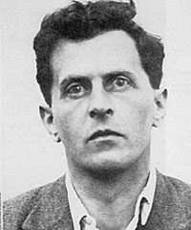Wittgenstein

5. Philosophy and language
Watch this scene from the dramatized account of Wittgenstein’s life.
- Does the language we speak define the world in which we live?
- Is ‘everything open to view’, as Wittgenstein argues?
- Are there any genuine philosophical problems?

6. Newspeak today
Read this Guardian blog on the way language is used by the US military, and how similar its usage is to Orwell’s 1984.
- Give some examples of the way the US military (and other authorities) pay more attention to the connotation than the denotation of words.
- What does this reveal about the power of language to influence our knowledge?
- Which institutions and groups of people in particular tend to use language in this very considered way?

7. Bilingualism
Read this BBC article on how speaking two languages can benefit the brain.
- What does the article say are the ‘non-language’ benefits of speaking in more than one language?
- What are the implications of this in terms of education policy?

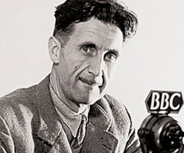George Orwell

8. Orwell on language
Read Orwell’s 1945 essay on the importance of language, and why we must work hard to halt its decline.
- Give some examples of what Orwell considers poor writing.
- Do you think Orwell is still correct when he says that political writing “is designed to make lies sound truthful and murder respectable”?
- In what way does Orwell believe that “language can also corrupt thought”?

9. The evolution of language
Read this Scientific American article on discoveries made about when we first started to communicate with each other using language.
- What was discovered, and what does it represent?
- How important is the ability to make ‘symbolic representations’ in terms of defining us as humans?
- What else makes us human – and can we order it into a hierarchy?

10. Monkey language
Read this BBC article on the development of communication in Campbell’s monkeys.
- How close are the monkeys’ communication calls to human language?
- What does this reveal about the way human language developed?
- Can we still say that language is one of the things that makes us human?

11. Defining science
Read this Guardian article on how the word ‘science’ should be defined.
- What is the definition of science according to the science council?
- Does it suggest science is a way of knowing, or an area of knowledge?
- Why do you think it took a year to decide on this definition?
- Why is language and vocabulary so important in the scientific world?

Is this when it begins?

12. Learning in the womb
Read this Science Magazine article on language learning in unborn babies.
- What does it suggest about when we first start to communicate using language?
- Does this fit into the idea that language is innate or culturally conditioned?

Language, Reason, and Emotion
Language is so much a part of human activity that it is easily taken for granted. The issues related to language and knowledge call for conscious scrutiny in order to recognize its influence on thought and behavior.
Nature of Language
- How have spoken sounds acquired meaning? What is the nature of the connection between the sounds and what they are taken to represent?
- Is it possible to think without language? How does language extend, direct, or even limit thinking?
- To what extent does language generalize individual experience, classifying it within the experience of the group? To what extent does a personal experience elude expression in language?
- Can language be compared with other human forms of symbolic representation, such as conventionalized gestures, sign language for the deaf, dance, painting, music or mathematics? What might language share with these other forms in the communication of what we know? In what ways might it be considered distinct?
- To what extent is knowledge implicit in language? For example, could it be said that 'Saturday is in bed' does not convey meaning, even though the sentence is syntactically correct, because of the prior knowledge that days of the week are not physical objects?
- How do computer languages compare with the conventional written and spoken languages of everyday discourse?
Language and Knowledge
- How does the capacity to communicate personal experiences and thoughts through language affect knowledge? To what extent does knowledge actually depend on language: on the transmission of concepts from one person or generation to another, and on exposure of concepts or claims to public scrutiny?
- How does language come to be known? Is the capacity to acquire language innate?
- If knowledge is based on an internal representation of the world does this imply that language is a necessary component of knowledge?
- In most of the statements heard, spoken, read or written, facts are blended with values. How can an examination of language distinguish the subjective biases and values which factual reports may contain? Why might such an examination be desirable?
- How apt is Voltaire's view that 'Error flies from mouth to mouth, from pen to pen, and to destroy it takes ages'?
Functions of Language
- What different functions does language perform? Which are most relevant in creating and communicating knowledge?
- What did Aldous Huxley mean when he observed that 'Words form the thread on which we string our experiences'?
- In what ways does written language differ from spoken language in its relationship to knowledge? Can control of written language create or reinforce power?
- Is it reasonable to argue for preservation of established forms of language? Is it reasonable to ask for one language common to the whole world?
- What is the role of language in creating and reinforcing social distinctions, such as class, ethnicity and gender?
- What is the role of language in sustaining relationships of authority? Do people speak the same way to inferiors and superiors in a hierarchy? Does the professional authority speak in the same way as the person seeking opinion or advice?
- What may have been meant by the comment 'How strangely do we diminish a thing as soon as we try to express it in words'? (Maurice Maeterlinck)
Language and Culture
- If people speak more than one language, is what they know different in each language? Does each language provide a different framework for reality?
- How is the meaning of what is said affected by silences and omissions, pace, tone of voice and bodily movement? How might these factors be influenced in turn by the social or cultural context?
- What is lost in translation from one language to another? Why?
- To what degree might different languages shape in their speakers different concepts of themselves and the world? What are the implications of such differences for knowledge?
Linking Questions
- In completing the sentence, 'I know that . . .', one is making a knowledge claim. Why is it useful or necessary to express knowledge claims? Are there Areas of Knowledge where it is expected or required? Are there Ways of Knowing where it is not?
- To what extent is it possible to overcome ambiguity and vagueness in language? In what contexts might ambiguity either impede knowledge or contribute to it? Does the balance between precision and ambiguity alter from one discipline to another?

Signs:
Here is a simple sign that convey meaning without words:
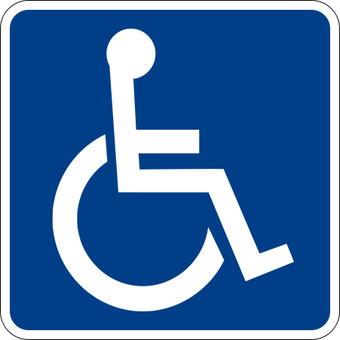

These are a little more complicated:

How many of these can we identify?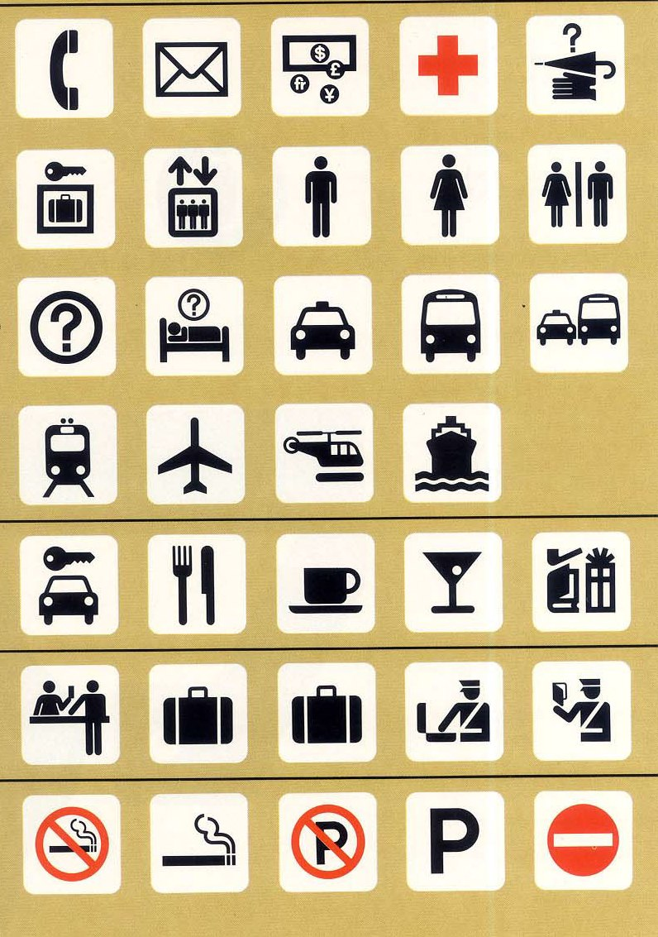

Here is an interesting project – redesigning bathroom signs. This was an art project and we don’t need to be concerned with technique. What is important here is the concept.
http://www.jaimetreadwell.com/2-D-RESTROOM-signs.htm

Here is a link to artist Mark Tansey, and a classroom activity.
http://amyscott.com/mark_tansey.htm

A link to an interview with George Laskoff about language, reason and computers.
http://amyscott.com/Body%20Brain%20and%20Communication.htm

How many of the following symbols are familiar to you? Is one significant to you or your community? Could anyone outside your community understand the symbol as you do? If not, then why not?

What does a flag symbolize? What is the relationship between a flag and what it symbolizes? Why can waving a flag, or burning a flag generate passion?
Write a manual on tying shoe laces for someone who has never worn shoes. Write the simpliest, clearest description possible. Ten minutes. Find a partner. One partner reads the instructions while the other follows them with a shoe. All instructions must be verbal.

Most annoying phrases in English:
http://opinionator.blogs.nytimes.com/2009/11/16/words-you-hate-to-hear/
http://opinionator.blogs.nytimes.com/2009/11/23/and-the-winner-no-problem/
Create a list of your own most disliked phrases.

An article about the harms of speed in communication:
http://online.wsj.com/article/SB10001424052970203550604574358643117407778.html

