Name: Date:
Sample IB Questions on Trigonometry
1. José stands 1.38 kilometres from a vertical cliff.
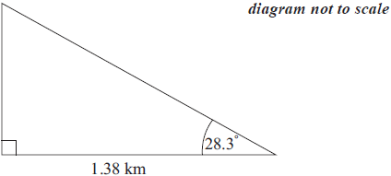
José estimates the angle between the horizontal and the top of the cliff as 28.3° and uses it to find the height of the cliff.
Find the height of the cliff according to José’s calculation. Express your answer in metres, to the nearest whole metre.
[3 marks]

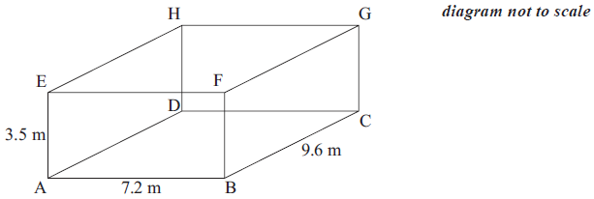
2. A room is in the shape of a cuboid. Its floor measures 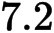 m by 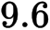 m and its height is 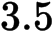 m.

a. Calculate the length of AC.
[2 marks]

b. Calculate the length of AG.
[2 marks]

c. Calculate the angle that AG makes with the floor.
[2 marks]

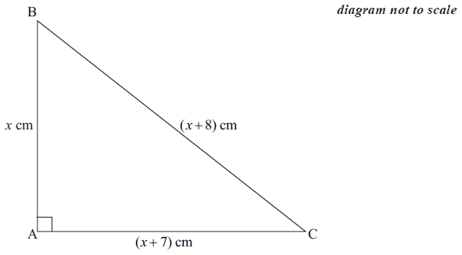
3. In the diagram, 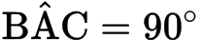 . The length of the three sides are , 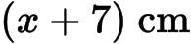 and 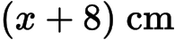.
a. Write down and simplify a quadratic equation in which links the three sides of the triangle.
[3 marks]

b. Solve the quadratic equation found in part (a). [2 marks]

c. Write down the value of the perimeter of the triangle. [1 mark]

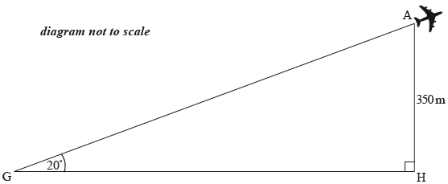
4. Günter is at Berlin Tegel Airport watching the planes take off. He observes a plane that is at an angle of elevation of 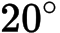 from where he is standing at point . The plane is at a height of 350 metres. This information is shown in the following diagram.
a. Calculate the horizontal distance, , of the plane from Günter. Give your answer to the nearest metre. [3 marks]

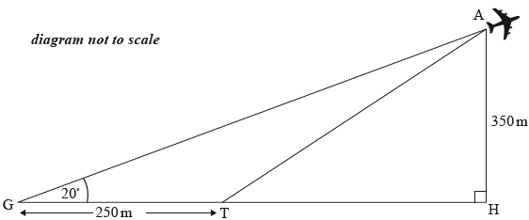
The plane took off from a point , which is 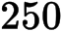 metres from where Günter is standing, as shown in the following diagram.

Using your answer from part (a), calculate the angle , the takeoff angle of the plane. [3 marks]

5. In triangle , , and 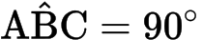.
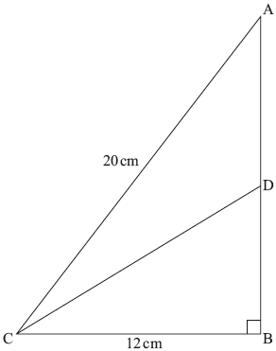
a. Find the length of . [2 marks]

b. is the point on such that 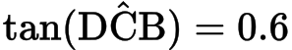.
Find the length of . [2 marks]

c. is the point on such that .
Find the area of triangle . [2 marks]

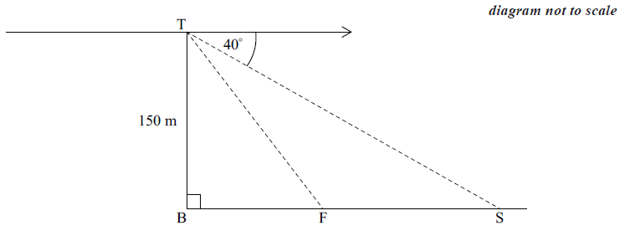
6. Tom stands at the top, T , of a vertical cliff 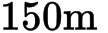 high and sees a fishing boat, F , and a ship, S . B represents a point at the bottom of the cliff directly below T . The angle of depression of the ship is 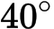 and the angle of depression of the fishing boat is 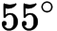 .

a. Calculate, SB, the distance between the ship and the bottom of the cliff. [2 marks]

b. Calculate, SF, the distance between the ship and the fishing boat. Give your answer correct to the nearest metre. [4 marks]

