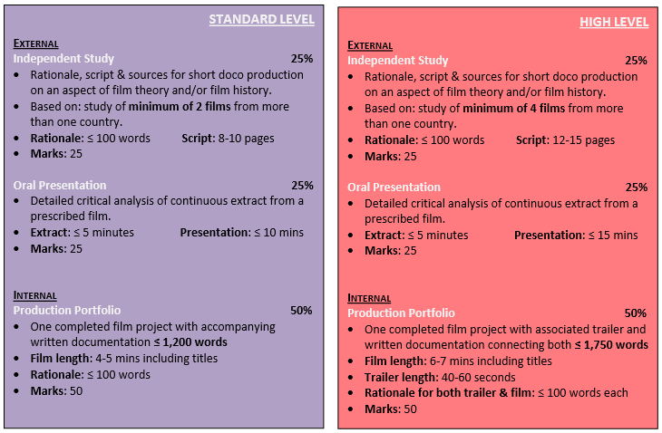

Discuss concept of academic honesty and intellectual property. No copywrited work may be used in your assessment. All assessments must be your own work.

Grades
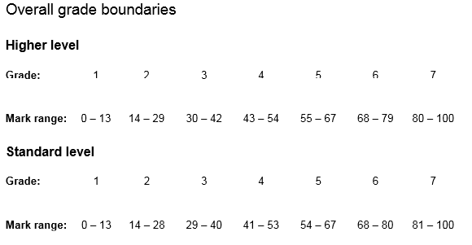

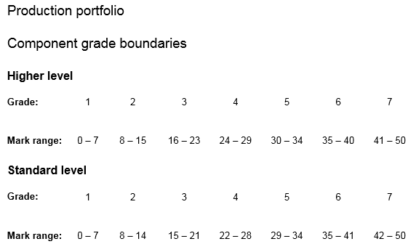
Note that for the Independent Study and for the Presentation, both SL and HL have the same grade ranges

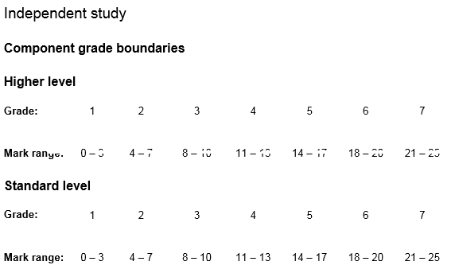

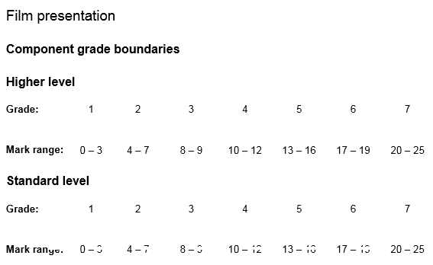

Film Production Portfolio
INTERNAL (50% of total IB grade)
Don’t try to make a full length movie in 4-5 minutes (SL) or 6-7 minutes (HL). Remember that running times must include credits. Trailers for HL films must include their own rationale (100 words or less) and be between 40 to 60 seconds in length.
The commentary portion of the Portfolio is just as important as the film itself.
SL lengths: Film (4-5 minutes, including titles), rationale (100 words) commentary (max of 1,200 words)
HL lengths: Film (6-7 minutes, including titles), rationale for film (100 words) commentary (Max of 1,750 words), rationale for trailer (max of 100 words).
For your rationales, remember to give a word count at the end of the rationale.

How you will be graded
Criteria: A) Planning, B) Reflection and Evaluation, C) Professional Technical Skills, D) Effective use of Film Language, and E) Creativity
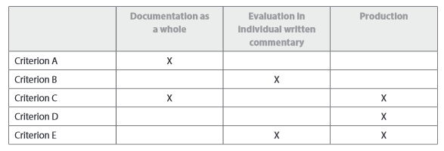

A - Planning and Research (assesses both film and written commentary)
This is concerned with the documentation of production processes, from planning and research, pre-production, production and principal photography, through to post-production. This includes planning and research required for the production of the film trailer. How much evidence of planning is there? For 9 or 10 marks you need to show: "Excellent planning for and research into the production processes for the film itself and the trailer. Documentation of the relevant development stages is comprehensive. Planning of production and documentation has all be clearly integrated with the production of the individual film trailer."
B - Reflection and Evaluation (just assesses the written commentary)
This is concerned with the artistic and logistical analysis of the various production processes. The evaluation in your written commentary on the project as a whole, focusing on your specific role. Reflect honestly. 'Artistic' refers to how you used film language to portray your ideas and emotions. 'Logistical' refers to how well the practical aspects of the project functioned. For 9 or 10 marks you need to show: "A highly effective artistic and logistical analysis of the relevant production processes, with excellent critical evaluation of the project as a whole. There is also a highly effective awareness and analysis of the different artistic and logistical processes required for the production of the trailer."
C - Professional and Technical Skills (assesses both film and written commentary)
This is concerned with professional and technical skills (including organizational skills) that may be demonstrated during the production processes of in the finished product itself.
For 9 or 10 marks you need to: "Demonstrate excellent ability in the professional and technical skills (including organizational skills) necessary for one principal production role, and make highly effective use of available resources and technology. There is also excellent use of available resources and technology in the construction of the individual film trailer"
D - Effective use of Film Language (just assesses the film)
This is concerned with evidence of your effective use of film language, as seen in the finished product.
For 9 or 10 marks you need to: "demonstrate an excellent ability to communicate effectively in film language both in the film itself and in the individual film trailer."
E - Originality and Creativity (assesses both film and written commentary)
This is concerned with originality and creativity in the film-making process (referred to as 'creative intelligence' below). This may be demonstrated by freshness of approach, by intelligent work that goes with or against the conventions of the genre, or by problem solving. Another key indicator is the level of audience engagement with the work. This criterion is also intended to provide a holistic assessment of each student's contribution to the finished film and of the trailer they have made as an individual.
For 9 or 10 marks you need to: "provide excellent evidence of creative intelligence in all aspects of the film-making process, and provide excellent awareness of, and imaginative use of, the generic characteristics of a film trailer. The film production and trailer engage audience interest with great success."
Roles
Roles of the candidate in the film must be a role that the candidate has done in previous film productions (either in class or outside). The candidate must be familiar with the role they are acting in for the production.
Here are some suggested questions to ask in your reflections for each of the five roles. Remember that each student reflects on only one of the five roles.
Writer – dialogue and setting the scene. Was the final edit of the film in keeping with your original vision? What did you find hardest about the writing process?
Cinemaphotographer – lighting, image creation and collaborating with director in blocking and composition. Once director has explained intent, the o Were you happy with all of the shots you took? Did the editor include any shots that you were not happy with? If so, why do you think he/she included them? Did the locations chosen serve any limitations on the shooting? Did you encounter any technical problems with your shoot? Did your equipment always function as it should? Did you ever wish you had a piece of equipment that you did not have access to? Was lighting ever a problem with your shoot? Did your vision for the cinematography align with the director’s? Were there any shots that you wanted to experiment with - such as use a dolly or steady cam - but found it technically hard to achieve? Why? Was lighting ever a problem with your shoot? DP describes how to go about created that effect visually.
Director – collaborating with Cinemaphotographer. Mise-en-scene and composition. Use the phrase “I directed…” in terms of giving direction to actors or the DP. Was the final film in keeping with your original vision? How well did your group react to your direction? Did you encounter any problems with actors? Were you able to get lighting/sound/location/costume/ issues resolved?
Were you happy with all of the footage? Were you able to stick to your shooting schedule?
Editor – pacing and defines focus. Creates meaning. Use a reference to the Kuleshove Effect in context. Did you wish to create a specific effect, but find the software limited in any way? Did you final edit of the film align with the rest of the group’s? Did you ever find yourself wishing there was an extra shot or another take that you could use? How did you overcome this problem? How hard/difficult was it matching up audio with visual in the editing room?
Sound Design – records dialogue, creates sound effects through foley and responsible for sound track. Be sure to use digetic and nondigetic in context. What specific problems did you encounter in the creation of your foley?
oere any sound effects (such a tires screeching/a gun shot/a knife wound/an echo etc) hard to replicate? Did the music/sound you created align with the group’s vision? Did you encounter any technical difficulties with equipment or software?
Here is an example of a nicely done first page – ignore the indentation variations.

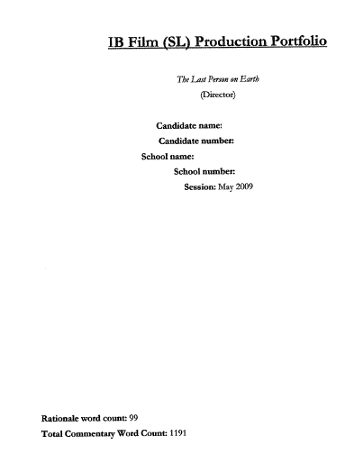
If this production were done at the HL level, there would need to be a separate rationale for the trailer. Discussion of the trailer should be integrated into the portfolio.

See this example on the IB Film website for a well written rationale for the film, and another rationale for the trailer:
http://mrsmithsibwebsite.weebly.com/uploads/1/2/3/9/12396431/hl_production_portfolio_sample_b_45.pdf

Components of the Production Portfolio
1) First is the coversheet, signed by student and teacher.
2) Film and trailer(if at HL) in DVD format, recorded on a labeled DVD disc. Each student must have their own copy of the film and trailer (if at HL). One DVD disc may however contain more than one student.

Each film and trailer must begin with a production slate – a pre-film credit sequence with a black background and white letters with the following information: Candidate name and session number, candidate role in the film, indicate if the film is for SL or HL, school name and number, title of film.
3)the commentary, which can be divided into the following parts:
Part One: rationale for film (followed by a word count). For HL you will also need a rationale for the trailer (followed by a word count). Max for both is 100 words.
Part Two: a) Pre-Production, b) Production and c) Post-Production
- Pre-Production
Initial planning
•Finding the idea
•Research
•Treatment and script development
Pitch and approval
•Developing the proposal
•Negotiating the proposal with the teacher
•Receiving approval to proceed
Technical planning
•Conceptualization – interpretation of the script in terms of theme, genre, purpose, style, mood and overall structure
•Visualization – definition of shot selection, camera position and movement, lighting, colour, set design, costume and make-up, supported, where appropriate, by the creation of a storyboard containing key images of relevant scenes
•Production Scheduling – definition of responsibilities, task lists and matter relating to organization, time frames and deadlines
•Editing and Sound Strategies – outlining the preliminary concepts of editing and sound as dictated by the chosen genre and by the individual project
Key Pre-Production Tasks
Selection of crew members, scouting for and determining locations, acquiring costumes and props, casting of actors (if applicable), definition of technical needs, finalizing script, storyboard and production schedule
Demonstrate that you took time to plan your project. Gather evidence in the form of pictures taken in pre, production and post, story board extracts and excerpts from the script. Use as many technical film terms as possible. Make references to other films that inspired you to try techniques in relation to your role. Each student must be involved in the creation of the music soundtrack, and explain their participation. You might play an instrument, collaborate on the performance, or help record the performance.

- Production: Principal photography and sound recording, execution of storyboard, continuous overview of production planning. Use photos, screen shots, storyboards and script excerpts to document.

- Post: Various phases of editing (assembly, rough and fine cuts), sound editing, selection of music, titles and visuals, and final mix

Part Three: Reflection and Evaluation. Throw in as many LP terms as possible. Comment BOTH on your specific contributions in terms of your role, and comment on the finished product as a whole. For HL you need to do the same thing for the trailer.
By the end of Parts Two and Three of your written production portfolio the examiner should have answers to the following questions:
1. What is the purpose of the film?
2. How did you plan to use (and how did you use) film language to convey this purpose to your target audience?
3. What filmmakers (films) or styles (genres) have influenced your creative expression?
4. Which choices in regarding the look and feel of the film (production design) have been deliberate?
5. Where did you have to take creative risks in order to solve problems?
6. What were the biggest challenges you faced during the making of your film? How did you overcome them?
7. What might you do differently next time?
What else might I want to include in the Written Production Portfolio?
You may also want to include a discussion or analysis of some of the following:
•Did you work with or against the conventions of the genre?
•How did the characterization of your protagonist/antagonist develop? Did the final result fit in with the writer’s initial vision?
•How did you successfully incorporate costume design into your film?
•What did you enjoy most about the making of this film?
•How well did you group work together?
•Was the Location Scouting and Selection a difficult process or did you always know where you would film? Was it easy to get permission to film where you wanted to? Was there a location that you really wanted to use but were unable to do so?

Max number of words for parts two plus three is 1,200 at SL and 1,750 at HL.

Part Four: References. Nothing in the references is included in the word count. Following is an example for formatting purposes -
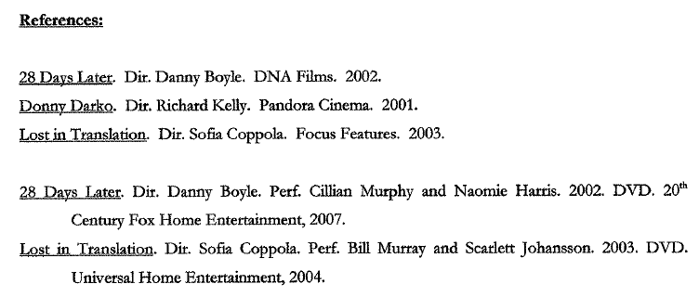
Side by Side comparison of SL and HL requirements for Production Portfolio
SL | HL
No trailer | 40-60 second trailer
No trailer rationale | Rationale for trailer (100 word max)
Rationale for film (100 word max) | Rationale for film (100 word max)
Written commentary (1,200 word max) | Written commentary (1,750 word max)
4-5 minute film, including titles | 6-7 minute film, including titles

External Assessments (25% for each)

- The independent Study

Students must produce a script for a complete short documentary production exploring an aspect of film theory or film history, based on the study of films from more than one country. The documentary should be targeted at an audience of film students in the 14 to 18 years age range. Among the topics students may choose to investigate are:
- genre
- theme
- direction
- use of sound
- colour
- editing
- lighting.
The topic should be discussed primarily in cinematic terms.
The prime voice of the documentary must clearly be that of the student, who is represented as the narrator, on-screen host and/or voice-over. Students must ensure that any comments or ideas they attribute to celebrities or others, such as experts, are fully supported by detailed references in the annotated list of sources.
Students at SL must make reference to a minimum of two films while students at HL must make reference to a minimum of four films from different countries. The chosen films must originate from more than one country.
The independent study must be presented in the form of a written portfolio composed of the following three items.
- Rationale
- Documentary Script
- Annotated list of sources. Go to this website for an example of formatting your annotated list of sources:
http://mrsmithsibwebsite.weebly.com/uploads/1/2/3/9/12396431/excellent_bibliography_film_script_1.pdf

The rationale must offer a brief, reasoned explanation of the concerns explored by the topic in no more than 100 words.
The script must clearly indicate the relationship between the audio and visual elements of the documentary, employing an established documentary format such as “side-by-side” columns for video and audio components. All descriptions of video and audio elements must be both detailed and specific. Scripts must be 8–10 pages long at SL or 12–15 pages long at HL, using an accepted size of paper (for example, A4 or US letter) and must use 12-point Courier font (not in block capitals) and single spacing. It is important that the student treats a topic of film history/film theory in cinematic rather than literary terms.
The annotated list of sources should refer to all materials used in researching the topic and all materials used in the documentary itself, including films from which extracts will be shown in the documentary and quotations from experts or academics. Annotations should give the source and/or location of the reference. A comment on the relevance of the source must be included.
Assessment of this component is based solely on the written script and the rationale. Actual films or film sequences are not acceptable.
The materials produced for this component must not be submitted for internal assessment as part of the production portfolio. As part of the learning process, teachers can give advice to students on a first draft of the independent study. Advice on improving the work can be given, but this first draft must not be heavily annotated or edited by the teacher. Constant drafting and redrafting is not allowed, and the next version handed to the teacher after the first draft must be the final one.
Preparation for the independent study
Introducing the independent study to students
The outcome of the independent study is a script for a complete short documentary production exploring an aspect of film theory or film history, based on a study of films from more than one country.
It is clear that there are two parts to the preparation for your students:
- independent research into their chosen topic
- presentation of their research in script form.
In your role as teacher you should:
- teach the documentary genre to your students so that they are familiar with the genre
- teach your students how to present a script in an appropriate format
- teach research methodologies and offer a suitable research environment in your classroom.
Choosing the topic
Teachers should give plenty of advice to students in the selection of their topic. More able students should be encouraged to consider topics that will give them the opportunity to develop their ideas fully; weaker students should not attempt projects that may be too complex. Ensure that the requirements of the syllabus are fully met.
Setting up a research environment
This component may appear rather daunting for students who are unfamiliar with the skills of independent research. Teachers should present students with an environment that helps them through this process.
If possible, students should have ready access to resources that will help set a project easily in motion, even if it is no more than a basic book box/library or list of useful Internet sites.
Teachers should remind students of the time limits for this work and discourage them from delaying making a start.
What you need to know
- develop sophisticated and high-level research skills
- use the Internet wisely
- know the rules of research, such as proper referencing and how to avoid plagiarism.
Students will need to display knowledge in their research. Teachers will need to guide them towards an understanding of what they have investigated, and advise them on how to demonstrate their understanding.
Teachers will need to show their expertise and deliver appropriate guidance and advice but also be able to stand back and let them find their own way.
Students will need to be taught strategies to enable them to take an independent approach to their research.
Students will need guidance in how to:
- formulate their specific area of study
- choose suitable films for study
- develop an hypothesis
- read different texts actively for different purposes
- support their ideas with evidence and analysis
- look for what is actually there in source material, rather than what they want to find
- organize their material right from the start.
Teachers will accompany students on their research journeys while they are reading, viewing, listening, questioning and discussing, with a view to showing their learning through their completed scripts.
The role of the classroom environment
The following are some suggestions for creating a classroom environment that values research and enables students to be independent learners.
Type of resource | Examples
Text resources | - Examples of research by previous students  - Abstracts of university theses  - A small library of key textbooks  - A range of magazines  - Posters with key learning approaches and phrases  - Glossaries of key terms  - Quotes by theorists  - Deadline dates
Image resources | - Contrasting film posters  - Movie stills and DVD covers  - Film magazine covers  - Moving image resources
IT resources | - Topic files containing copies of Internet print-offs by students  - Lists of recommended websites
A step-by-step approach to research for students
The very first step is choosing an appropriate topic. This is often harder than it appears. Students should be encouraged to look towards their own interests initially, or towards an area that the teacher believes they would enjoy, given the teacher’s understanding of their abilities and interests.
Once a topic has been broadly decided upon, research can begin. Students should be encouraged to change direction if they are finding the topic too problematic and if the teacher is unable to resolve the problems.
Steps in the research process | Issues to consider
Define the topic | - What is the bare outline of the area for discussion?  - Break down the topic into sub-topics or key concepts.  - Develop a broad overview of the topic by browsing sources.  - Become fully conversant with the necessary terminology.
Develop a research strategy | - What is the scope of the project?  - How much information will be needed?  - What is the appropriate level of the project?  - How manageable is the project?  - Can it be fully developed given the limits of the script?
Locate and retrieve the information | - Determine what type of information is needed—books, articles, current or archive information.  - Identify the likely and unlikely sources or places to find information.  - Ensure that you have all the information you need including the full citation of any references that are collected. When photocopying always write down the title and author of the book.
Evaluate the information | - Establish authority—who is the author and what is their credibility?  - Determine the scope of the work—what is its purpose?  - Evaluate accuracy and relevance.  - Recognize bias and/or point of view.
Determine whether there is enough information | - Look at the length and focus of your topic.  - Are there any unanswered questions?  - Does your topic represent only one point of view?  - Could you include anything further?
Internet research
Web pages require the same, and sometimes more, caution as any other source. Anyone with access to a server can put material on the Internet. Do not assume statements are true. As a critical user a student should consider the following.
- Who is responsible for the site?
- What is its rationale/purpose?
- Is the information recent or part of an archive?
- Is the site permanent or part of a permanent organization?
Teaching tips
The teacher can help students by:
- establishing firm deadlines for handing in bibliographies, rough drafts, and so on
- identifying high quality source material that is reliable and authoritative
- advising students when to stop researching and when to move on to discussing their findings and preparing the script.
Students should be reminded that their topic is going to be presented as a script for a documentary and not as an essay with visual wallpaper.

How to get the top grade in Film Independent Study

Marks | Level descriptor
1-5 | - There is little or no understanding of film history/theory topic  - Engagement with the target audience is limited  - Scope and depth of argument is limited  - Use of sources are limited  - Structure of the script is limited  - Visual and audio elements are incompletely described and poorly linked  - Films referred to have limited relevance to the topic  - There are very few relevant points of comparison made between the chosen films
6-10 | - There is some understanding of film history/theory topic  - Engagement with the target audience is occasionally relevant but still limited  - Scope and depth of argument is occasionally relevant but still limited  - Use of sources is occasionally relevant but still limited  - Structure of the script is basic  - Visual and audio elements are fairly well described but inconsistently linked  - At least 2 of the films referred to relate to the topic  - There are some relevant points of comparison made between the chosen films
11-15 | - There is adequate understanding of film history/theory topic  - Engagement with the target audience is adequate  - Scope and depth of argument is adequate  - Use of sources is adequate  - Structure of the script is adequate  - Visual and audio elements are well described and satisfactorily linked  - At least 3 of the films referred to relate to the topic  - There are mostly relevant points of comparison made between the chosen films, although they may be superficially or incompletely developed
16-20 | - There is good understanding of film history/theory topic  - Engagement with the target audience is good  - Scope and depth of argument is good  - Use of sources is good  - Structure of the script is good  - Visual and audio elements are clearly and coherently described and mostly well linked  - All films referred to clearly relate to the topic  - Points of comparison are explored with care and coherence
21-25 | - There is excellent understanding of, and engagement with, film history/theory topic  - Engagement with the target audience is excellent  - Scope and depth of argument is excellent  - Use of sources is excellent  - Structure of the script is excellent  - Visual and audio elements are detailed, clearly and coherently described, and proficiently linked  - All films referred to clearly relate to the topic  - Points of comparison are insightful and are made coherently and with precision

Meeting the requirements: Any student who does not meet all formal requirements may not be awarded within the top two mark-bands. These requirements are:
- Correct length
- Correct format
- Inclusion of the rationale
- Annotated list of sources
- Number of films required for study
- Reference to films from more than one country

