Individual Rationale for Listen

Listen is a film that uses different aspects of the silent film, incorporating the use of sound and music to give a voice to the characters. By attributing music as the sound of their voice, we highlight how communication is broken. The expression through music and non-verbal communication allows creating a different idea that combines music and film. The story is effectively portrayed through the mood of the music and the capturing of the actor’s emotions through film language. With this film I wanted to show the importance of communication between human beings, portrayed through music.
Word count: 96

Individual Rationale for Listen trailer

With the trailer I wanted to show the particular uniqueness of the movie. I wanted to highlight the nature of non-verbal communication that the movie exploits. With the trailer, I want to show some characteristics of the story and relationships between the actors without giving anything away about the plot. I would use specific transitions very carefully to help smooth the cadence of the music and what goes on the trailer. I centred the idea of my trailer in the statement “93% of human communication is non-verbal”. This statement exploits the whole concept of the movie.
Word count: 96

WRITTEN COMMENTART FOR LISTEN

The purpose of my film was to show the importance of communication in a relationship. Doing a silent film where the music would be the voice of the characters was something really original that we thought as a group. The story of the film is a cliché dramatic/romance with a couple that is falling apart, but finally they get together. Using music, as a pathway is what gives the movie the meaning that gives originality and meaning in terms of film language. It’s fusing art with art. Making a hybrid between a romance and a modern silent movie is something that works as a pathway to show the importance of communication in human relationships. To show how important the communication is to human beings. The title Listen came from the original score. When I had edited the whole film and I started to compose the music for it, I noticed that you would have to Listen the whole time. The music that I put into it, I believe, gave more meaning to the relationship between the characters because of the musical relationships seen along the whole movie. We exploited the idea of non-verbal communication for exploring and discovering a new genre that would mix drama-romance with German expressionist silent movies as well with contemporary elements of a score that shows a rock/electronic/symphonic/musical type genre. Aside from music, I wanted to show the influence of German expressionism and the way silent movies are accompanied with perfect matching music scores.
Pre-production:
On this stage I started an extensive investigation of what I would have to do as a sound engineer to achieve the concept that is explored in the movie. The best option to do this was to have deep research in various elements that would help me to explore the ideas that are developed in the movie. I then found inspiration and went back to some German expressionism for the synchronous scores, especially in the movies Nosferatu (1922) score by James Bernard in 1997 or Metropolis (1927) original score version of 1927 by Gottfried Huppertz. With these two movies I explored how the composers would apply music to elevate tension, such as in the stair scene of Nosferatu, by the use of violins plucking in elevated tension. Also in Metropolis, the score would represent the elements and props in the movie. This would be an element that I would use throughout the movie. In terms of different influences I explored contemporary scores such as Danny Elfman’s score on Spiderman (2002), which shows a high level of production in terms of symphonic performance. Also, the scores of Alexandre Desplat in several movies such as Harry Potter: Deadly Hallows pt 1 and 2 and The Curious Case Of Benjamin Button. His influence brought me closer to explore a contemporary, dramatic sound that brought inspiration to the composition of most of the parts. I also found really important considering other genres that include, extreme death metal such as Arch Enemy for its virtuoso musician techniques and progressive metal bands such as Dream Theatre and Symphony X for a very educated mix of the tracks and elevated instrumental contributions.

In terms of the story of the film having vague characters that represent specific emotions, helps the music along with the images to tell the story. During pre-production, mostly, I created a mapping of sounds that would belong to each character, and that it would represent the character in the whole movie, for example, when Tom throws a cushion I would always use a timpani hit along with harmonized guitar bends.
Production
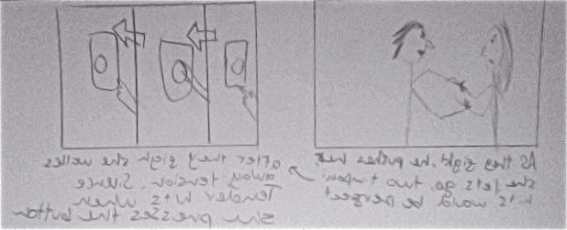
As an editor and musician, I found really important to get involved in the project deeply. During this whole process I found most important to start developing a structure, the skeleton of the score, and as the film was shot, I would talk to the screenplay writer to discuss and establish the moods between scenes and what might be used for each aspect. In deeper analysis, we discussed the sounds that could be used, the leit motifs that would appear throughout the whole film, and how sound could start being the main character of the production. One of the biggest challenges in the planning of the score for the film was during the end of the first part (in the picture above) I planned which would be the best idea to have a transition from one section to the other. During the process of the filming, I went to the filming days and started conceptualizing the ideas and music. Every time they used to film, the screenplay writer and I would get together as the filming was made and we would discuss which ideas we wanted to apply. This helped the story to be constructed better from within. It was really helpful, to have contact with the director, because he could exactly tell me which good inputs he had for the movie, and the depth that could be explored if some other sounds were made. The equipment that I used, I believe was the best, because I can record everything I want, every instrument. I think by having all this equipment, the creation of the full score was easier to make. The quality and sound of the instruments I used was definitely close to a professional mock-up because of my gear.

Pictures of my gear (photographed by me)
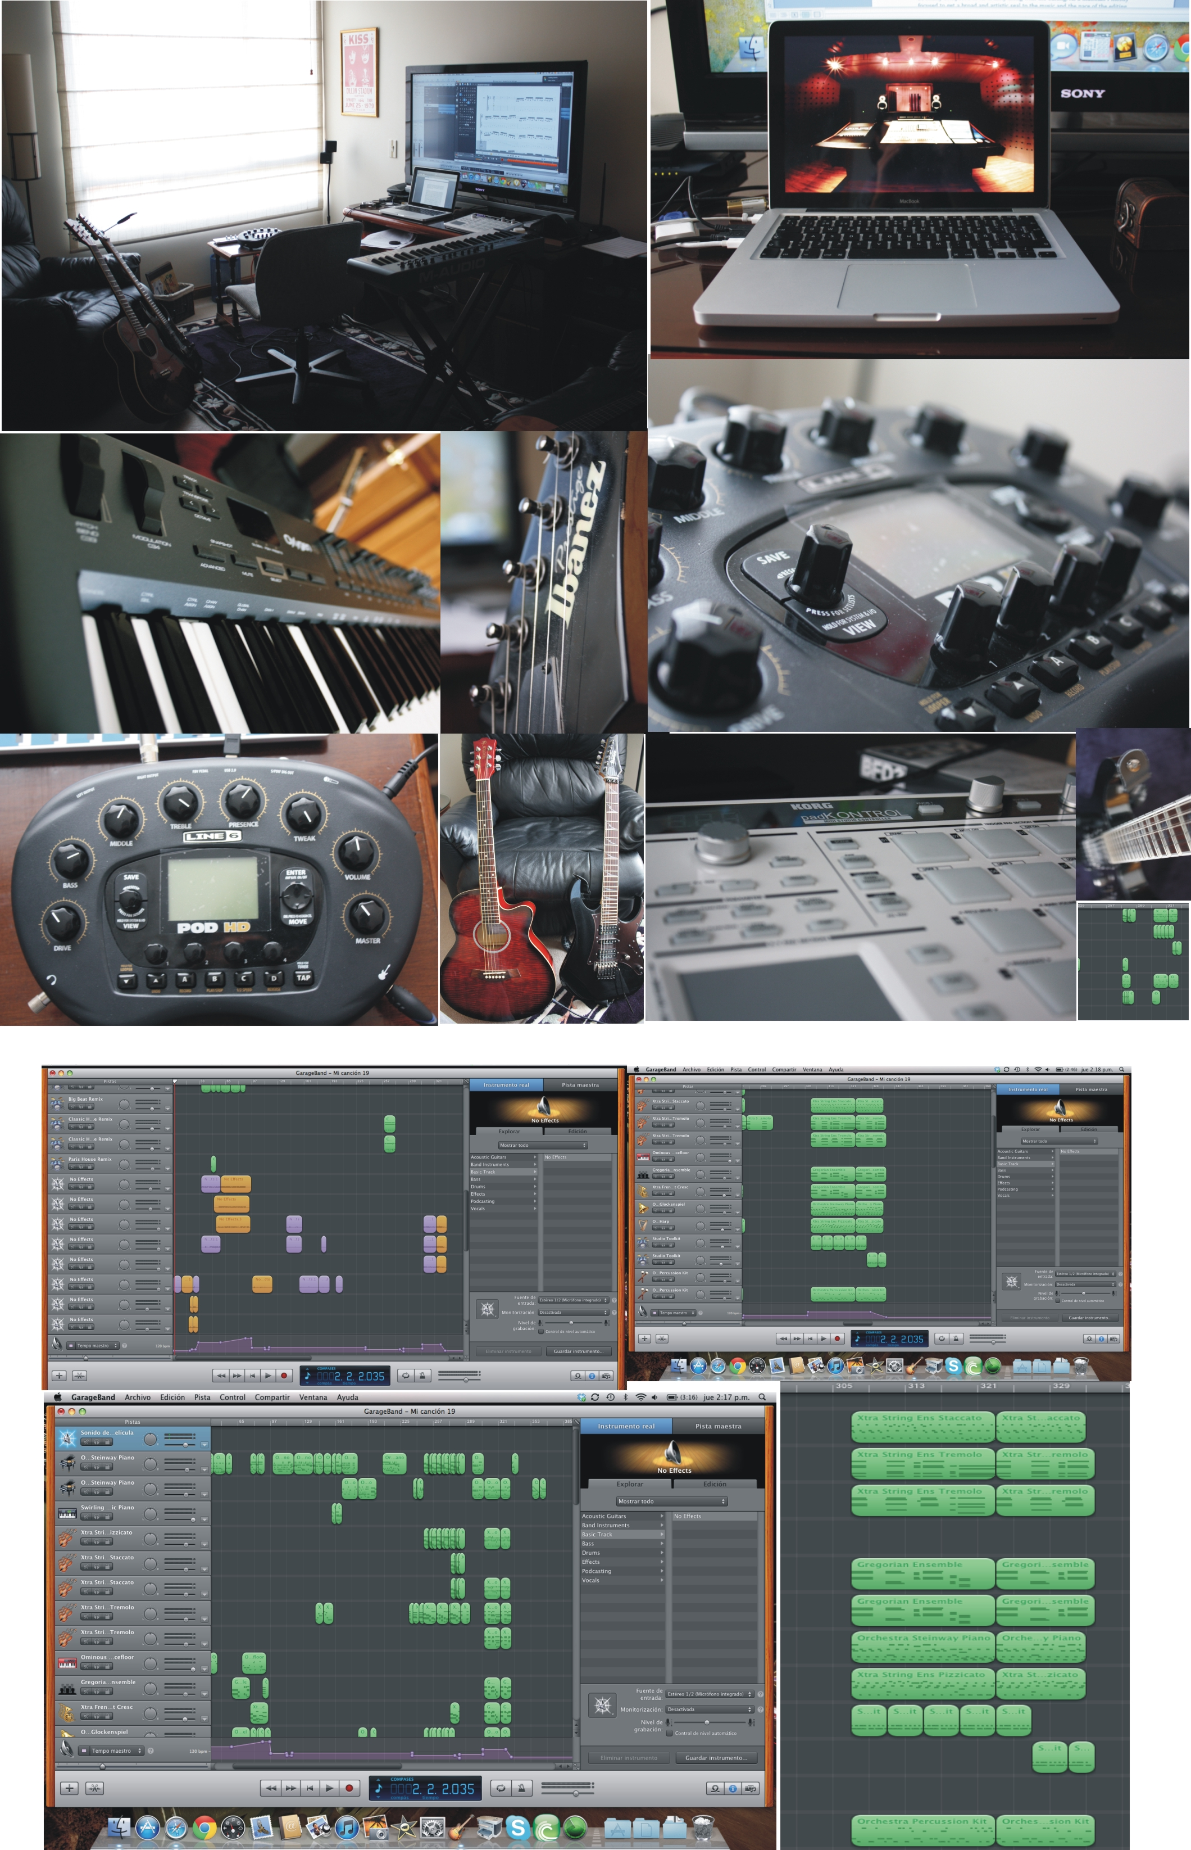

Post-production
As a musician I mostly focused to get a broad and artistic seal to the music and the pace of the editing. For this, most of the frames and the scenes would be synchronized perfectly with the film. Every time there would be a camera change, the music would be rearranged so that the bars and the beats per minute would fit the sequences. Logistically, I made a garage band session with the film scoring properties and a compilation of 45 software instruments from “tremolo strings” to “beat breaking mix drums” and 25 other guitar tracks. In scene 1, the protagonist writing the letter, I would use a melancholic guitar/piano duet that would highlight the sadness of this character. When the character starts writing backwards, in the editing field I decided to do this to highlight the miscommunication and the lack of expression in language. As for the music, I wanted to create the same “backwards” effect by using high amounts of reverb in the guitars, which could be compared as the sound recorded in a cave, which artistically represents the isolation of the character. I use different hits along the whole movie to represent the anger and the nature of the main character, when he starts writing and the main title comes out, when he crushes and throws the ball of paper and when he throws the cushion. This gives an effect of force and it’s a leit motif used in the movie. As for other leit motifs, I used a clock ticking.
This is a collage of screenshots of the GarageBand session:

This was mainly inspired by the title of the book of the woman “tik tok”. I would use a clock ticking in two sections, the accelerated sunset and the wife waiting when he comes back home and showing the time passing. I got the clock sound from logic express loops and I modified it with several effects such as reverb. I did the same with the sounds of the flashbacks, where I inverted and gave different effects for an explosion sound. It is used to show an accelerated pace of time, and also how the wife was desperately waiting for her husband. This highlights the nature of the wife, which shows the deterioration of their relationship and her concern to be with his husband. I also used the music as a vessel to develop language and communication/dialogues between the characters. In the first fight I would use a prog-rock feel that would explore the sentiment and struggle between both characters, and I would represent the sound of their voice as a synth, and the sound of his as a guitar solo. I would then create a faster pace in the rhythm highlighting the nature of violence in the relationship, resulting in a climax where they both shake themselves physically, ending in two harsh percussion and guitar simultaneous hits. As for the lover, I explored using guitar relaxing sounds, piano open chords that could relate to the feeling of the character and the later character development. The section that was the most important in relationship to the sound engineering of the whole score was just after expectations and really. With this whole orchestral section in perfect mix, I would show exactly the perfect climax that would represent the feelings of the character. The arpeggios create a sense of confusion and could create a feeling of “tearing down the structure” where the whole nature of the character would be broken down to come back to where he belongs. The most important section in the whole score was the resolution, where both characters meet again in a loving embrace. I needed to represent this section as a resolution that would show how the characters now could listen to each other. For this, I applied a happy, rock feels section that showed the excitement and the love and passion between this two characters resulting in a loving kiss. The part that makes me the proudest about my work, I call it “The Spiderman” scene; this is when reality and expectations ends, and the lead character starts having flashbacks about his wife. This is my favourite part music wise, because the engineering of the sounds is the best I’ve ever done; it is as if a whole orchestra is playing my music. This part in the movie, made a really dramatic great effect in the film as a whole since it was the turning point of the characters.
I am very pleased with my role and the logistic and creative development of the whole movie. I think this project has allowed me to grow as an editor and as a musician. I think that I can already apply the knowledge of film maybe in the editing for one of my next music videos. Listen is a very good example of creating universal hybrids that expand and pioneer the view of film universally. This film is a demonstration of how genres are mixed together and how different types of film scoring and film can be put together. This movie definitely shows deeper strengths were the music turns into a main character of the story.

Bibliography:
http://www.filmsite.org/bestspeeches75.html
http://www.radford.edu/wkovarik/class/history/treasury/mh.cinemahistory.html
http://www.imdb.com/title/tt1022603/

